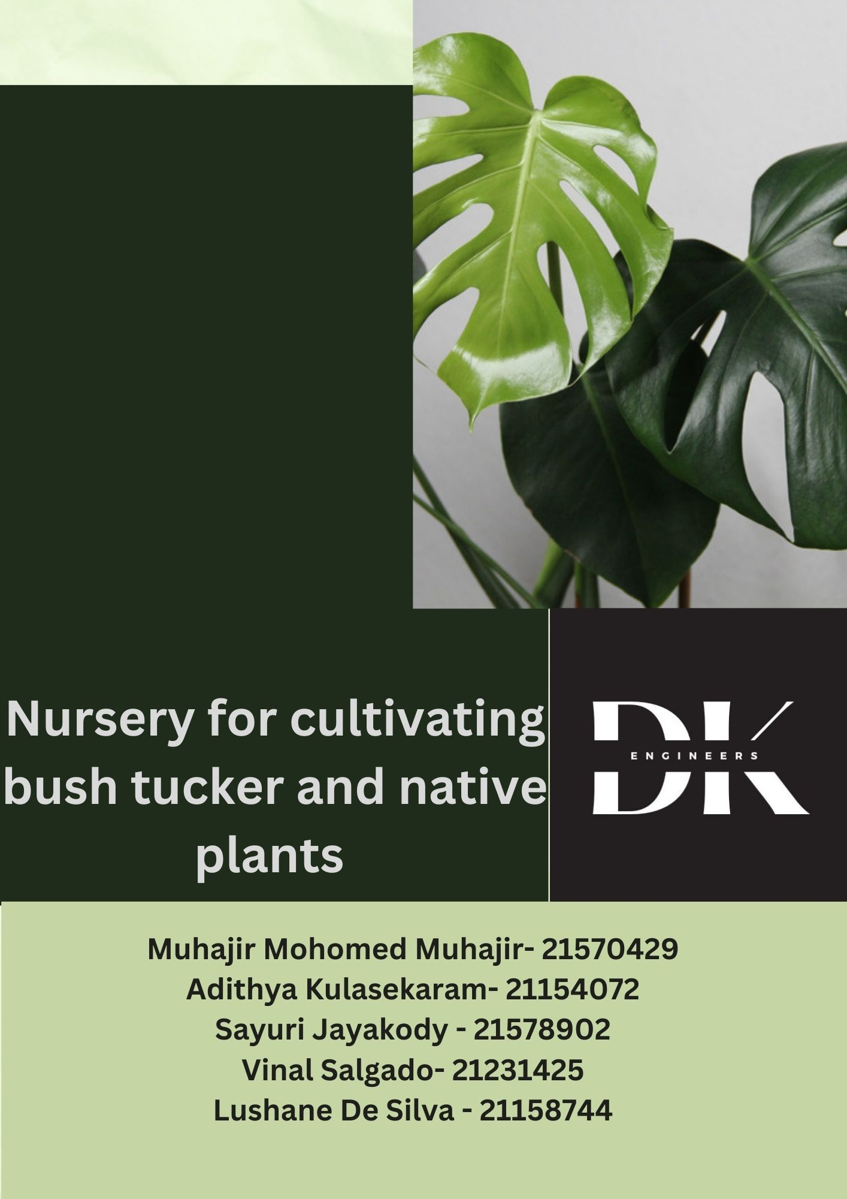

**Executive summary**

The Yirrganydji land country is facing a severe challenge as their natural supply of bush tucker is decreasing. The root cause of this is due to climate change and urbanization, which is having a significant impact on the environment and the natural occurrence of these native plants. Bush tucker is essential for Indigenous communities as it is one of their sources of food. Losing it is causing a lot of problems for these communities as it has significant social, cultural, and economic implications.

Climate change is making weather patterns unpredictable and causing extreme weather events. These events are destroying habitats and leading to the loss of plant and animal species. As a result, the availability of bush tucker is getting affected. On top of that, urbanization is leading to the clearing of land for development, which is making it even harder for the Indigenous communities to access bush tucker. This is an important issue which needs to be resolved, hence the design project assigned by the EWB challenge organization is centered on building a plant nursery to promote sustainable cultivation of bush tucker.

Also, this will be a viable economic opportunity through the establishment of a community-based nursery for growing native plants and bushfood. The nursery's potential to expand its product range and form alliances with nearby companies can generate income and support the local economy. Additionally, the cultivation of native plants and bushfood preserves Indigenous cultures' cultural practices and traditions, benefiting the environment.

The project's success depends on variables such as availability of natural resources and support from the local community in maintain the bush tucker nursery . Stakeholder engagement and remote project oversight are also limiting factors to consider.

To address these concerns, our team developed a design that meets five main criteria and relative weightage to it: sustainability (30%), resource availability (20 %), safety (20%), economic viability(10%) and cost (20%). We prioritized sustainability to ensure the project's success.

The success of the community-based nursery proposal relies heavily on meeting the needs and interests of its key stakeholders. These include environmental groups, the Dawul Wuru rangers, the local government, and the Yirrganydji community.

Environmental organizations have a keen interest in safeguarding biodiversity and promoting environmental sustainability. Their expertise and support can be critical in ensuring the project is ecologically sound.

The Dawul Wuru rangers are responsible for managing natural resources in the Yirrganydji land country. Their involvement can help ensure that the project aligns with Indigenous cultural practices and traditions.

The local government has a responsibility to support sustainable development in the region. By providing necessary resources and infrastructure, they can help make the project viable.

Lastly, the Yirrganydji community is the most important stakeholder in this project. As the traditional landowners, their participation is vital to ensure the project is culturally sensitive and socially sustainable. Their support can also play a critical role in the project's long-term success.

Moreover, our proposed solution of using an aquaponic system in the nursery is a viable way to address the depletion of bush tucker due to climate change and urbanization.

The aquaponic system is an efficient and sustainable method of farming that requires less water and space than traditional methods. It operates as a closed-loop system, where the fish waste fertilizes the plants, and the plants filter the water for the fish. This symbiotic relationship creates a highly efficient and productive system that produces both fish and plants for consumption.

The benefits of the aquaponic system extend beyond its efficiency and productivity. It is also low-maintenance, making it a practical solution for a community-based project that requires minimal resources and labour. This system provides a sustainable and innovative solution to the environmental challenges facing the Yirrganydji land country.

By combining a community-based nursery with an aquaponic system, we can create a sustainable and innovative solution to address the depletion of bush tucker in the region. This approach presents an opportunity to not only preserve the natural resources but also generate economic opportunities for local business owners and their staff. Our team believes that this project has the potential to promote social, economic, and environmental sustainability in the region.

Table of Contents

Section 1: Introduction 5

Section 2: Project Background 5

Section 2.1 - The Problem 5

Section 2.2: Factors Effecting 6

Section 2.2.1: Resources of Yirrganydji 6

Section 2.2.2: Population of Yirrganydji. 6

Section 2.2.3: Education System in Yirrganydji. 7

Section 2.2.4: Geography, Environment, and Climate of Yirrganydji. 8

Section 2.2.5: Economic Background of Yirrganydji. 10

Section 2.2.6: Political Background of Yirrganydji. 10

Section 2.2.7: Culture, Religion, and Language of Yirrganydji. 11

Section 3: Stakeholder Analysis 13

**3.1 Environmental organizations** 13

3.1.1 (ANPSA) Environmental organizations what they want in this project, 13

3.1.2 Australian Native Plants Society (ANPSA) Environmental organizations power and their intrests 14

**3.2 Indigenous communities.** 15

3.2.1 Introduction 15

3.2.2 Indigenous communities (Yirrganydji tribe) what they want in this project, 15

3.2.3 Indigenous communities (Yirrganydji tribe) power and what about their interest 15

3.2.4 How would the stakeholder be affected if no solution was found? 16

3.2.5 If a solution was found, how would that affect stakeholder 16

**3.3 Local Government** 16

3.3.1 Introduction 16

3.3.2 The Cairns Regional Council what they want in this project 16

3.3.3 The Cairns Regional Council power and what about their interest, 16

3.3.4 How would the stakeholder be affected if no solution was found? 17

3.3.5 If a solution was found, how would that affect stakeholders? 17

**3.4 Commercial industries** 17

3.4.1 Introduction 17

3.4.2 Commercial industries what they want in this project 18

3.4.3 Commercial industry’s power and interest, 18

3.4.4 How would the stakeholder be affected if no solution was found? 18

3.4.5 If a solution was found, how would that affect stakeholders? 18

**3.5 Dawul Wuru Rangers** 19

3.5.1 Introduction 19

3.5.2 Needs and Wants 19

3.5.3 Impacts of the Project on the Stake Holder 20

Section 4: Design Requirements 20

4.1 Design Criteria 20

4.1.1 Sustainability 21

4.1.2 Safety 21

4.1.3 Resource Availability 22

4.1.4 Cost (capital and operational) 22

4.1.5 Economic Viability 23

4.2 Design Constraints 23

4.3 Design Criteria weighting summary table 24

Section 5: Design concept solution 25

5.1- Outline of Concept 25

5.2 Conceptual Drawing Budget 27

Section 6: Model drawings and Specifications 29

6.1- Drawings (Sketch up and AutoCAD) 29

6.2 Specification 39

6.2.1 Bill of Quantities 39

6.2.2 Tools List 41

6.2.3 Methodology 41

Section 7: Tender Evaluation Criteria 45

7.1 Technical capabilities: 45

7.2 Cost effectiveness: 46

7.3 Ability to meet deadlines: 47

7.4 Communication 47

Section 8- Conclusion 48

Section 9- References 49

Section 10-Appendices 51

APPENDIX B- Concept design of team members 51

APPENDIX C Table of contributions from each member 55

# Section 1: Introduction

The Dawul Wuru Aboriginal Corporation, who are the keeper and care-takers of Yirrganydji Country, are facing multiple challenges that pose a threat to their land and culture. Among the most pressing concerns is the changing land use, brought about by urbanization and climate change, which has caused a drastic decline in the availability of bush tucker. This is concerning because bush tucker is a crucial component of the local cuisine and an essential part of their cultural heritage and well-being.

In addition, the loss of traditional land management practices has resulted in the degradation of the local ecosystems. This degradation has had a detrimental effect on the environment, causing a decline in essential services such as clean air, biodiversity, and healthy forests. The Dawul Wuru community relies on these natural resources for their sustenance and cultural practices, and the impact of this degradation is felt profoundly by them.

To address these challenges, the Dawul Wuru Aboriginal Corporation is embarking on an innovative solution. They are exploring the possibility of establishing a nursery to cultivate bush tucker and native plants. This approach promotes sustainable land management, while also supporting the community's well-being and cultural connections to the land. The nursery will serve as a platform for the community to grow their own produce, and it will also serve as an education and cultural hub.

This report aims to examine the design and implementation of this solution and its potential to create positive outcomes for both the Yirrganydji people and the broader community. By promoting sustainable land management practices, cultivating bush tucker, and restoring traditional land management practices, the Dawul Wuru Aboriginal Corporation hopes to secure a brighter future for their land, culture, and community.

# Section 2: Project Background

### Section 2.1 - The Problem

Yirrganydji community is placed in far north of Queensland, The location might also be attractive to tourists at the same time! It has an incredible and vast biodiversity. For instance, native plant species and bush tucker and other Endemic animal species. (Department of Environment and Science, 2013), the Great Barrier Reef, and mangrove swamps, which also have some unusual biodiversity. They face Significant difficulties with transportation, communication, accommodations, wild fires and lack of land due to urbanization and deforestation, our main objectives in this project are to draw attention and awareness of the importance of bush tucker and native plants, as they are food sources with high nutrition to the community and these plants hold a special place in their culture.

## Section 2.2: Factors Effecting

### Section 2.2.1: Resources of Yirrganydji

One key strength of this region is the availability of regular humanresources. The majority of the region's natural resources, including as islands, seashores, streams, and waterfalls, are first displayed alongside indigenous wildlife and plants. The region is home to a variety of residences and is a protected area for the Great Barrier Reef Marine Park and Wet Tropics Rainforest. The Coral Ocean, Torres Strait, and Gulf of Carpentaria surround being a Yirrganydji. This includes "The Incredible Barrier Reef," the most famous and well-known coral reef. This coral wonderland is frequently referred to as a submerged rainforest since it contains a diverse ecosystem that is unique to this location on Earth. Therefore, it is clear that the sea is a crucial factor for it's rich biodiversity. In addition, as previously mentioned, "The Great Barrier Reef" is a world heritage site and the natural habitat of some animal species. In addition to providing spawning grounds for numerous animals species, mangroves provide home to a wide variety of birds and other untamable animal life.

### Section 2.2.2: Population of Yirrganydji.

As of June 30, 2018, the Cairns region had 165,525 assessed private residents. Over the past ten years, the area has experienced a 1.9% annual growth rate. Up to 50,000 people may eventually be required to live in the Mount Peter Master Planned Area, with the Cairns district expected to host 66% of Tropical North Queensland's population growth.

### Section 2.2.3: Education System in Yirrganydji.

In this region, 40% of the Yirrganydji or other tribal communities,have completed 12 years of formal education. The vast majority of people still lack English literacy. The history of Indigenous training programs in Yirrganydji is replete with instances of neglect, failure, and fundamental underfunding. Every Aboriginal child deserves the best possible education, and this has never been the case before. Native Australians in distant Australia have a really tough time fitting into this educational system. From one perspective, education can provide enormous financial benefits, a path to social adaptability, and a means of reducing social disadvantages. In Yirrganydji, there are a large number of Indigenous pupils from a range of social, economic, and geographic backgrounds. These youngsters come together with educators, parents, strategists, and government representatives to create what is frequently referred to as "Native schooling." However, education that doesn't take into account learning in your native tongue and that doesn't take into account your social, interpersonal, and financial characteristics isn't interesting. It is crippling. Tragically, even after more than ten years of using these approaches, Indigenous instruction continues to have poor levels of engagement, inconsistent standards, and educational and numeracy outcomes that fall far short of those of other Australian cultural groups.

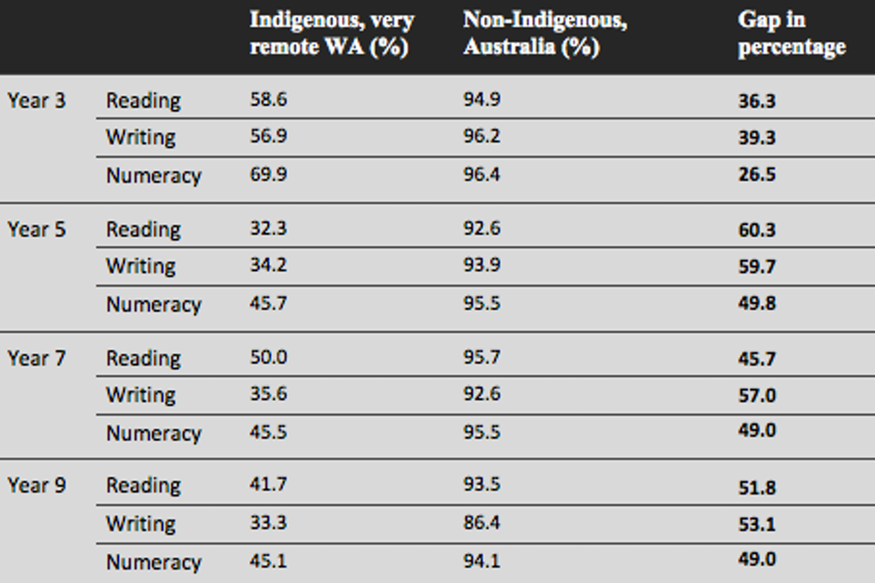 *Figure 1: The image above describes the education level of indigenous and non-indigenous people*

Section 2.2.4: Geography, Environment, and Climate of Yirrganydji.Section 2.2.4.1: Geography

According to Norman Tindale, Irukandji nation covered an area of around 200 square miles (520 km), stretching from Cairns to the Mowbray River in Port Douglas. Their inland enlargement circumvented the Barron River's running waters near Redlynch and traveled nearly 7 miles northwest of Cairns. ("Geography & population", 2022)

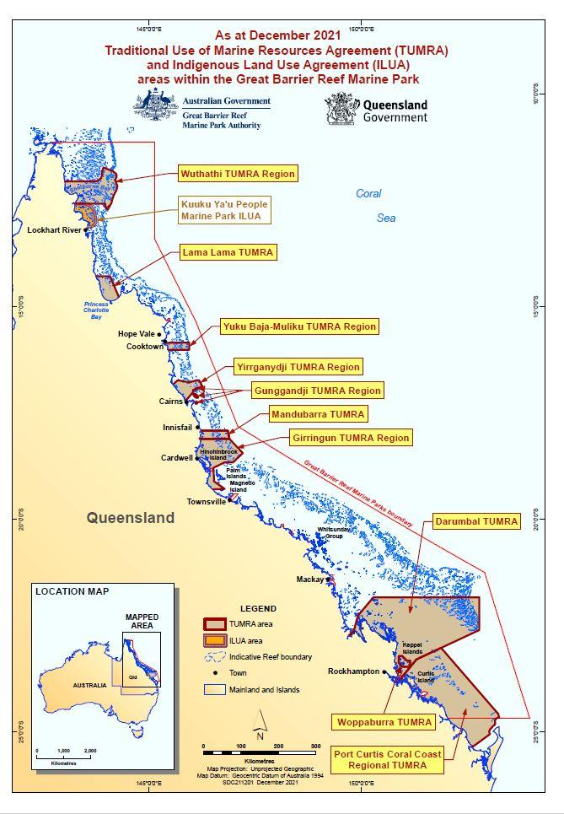

*Figure 2: The above image is a map of Yirrganydji*

#### Section 2.2.4.2: Environment

Cape York Promontory, located at the northernmost point of Queensland, is a rare wild area with extraordinary species contrasts that are globally, regionally, and globally significant in particular of eight signature inheritance measures.The area is primarily covered in eucalyptus trees, but it also has notable rainforest, heathlands, fields, wetlands, and mangrove vegetation. The area is primarily covered in eucalyptus trees, but it also has outstanding rainforest, heathlands, glades, wetlands, and mangrove vegetation. Gondwanan and Unused Guinean plant parts,as well as notable orchid variations, can be found in rainforest vegetation.

#### Section 2.2.4.3: Climate

Queensland's Yirrganydji traditional landscapes and waters extend along the coastline from Cairns to Port Douglas. According to the Yirrganydji occasional timetable, there are two major seasons: Kurrabana (wet season), which lasts from November to May, and Jawarranyji (storm period) and Jimburralji (minor seasons). (tornado time). The dry season, known as Kurraminya, lasts from May to November and has three minor seasons: Jinjim (winter), Yiwanyji (breezy), and Wumbulji. (hot time).

### Section 2.2.5: Economic Background of Yirrganydji.

The United Nations has recognized Yirrganydji as one of the most notable regular regions in the world since the 1980s. There have since been the usual political power struggles over how to see these features. Native Americans were successfully driven from the land in the nineteenth century. Today, mining and touching are out of control in the area, frequently in ways that don't benefit local networks but pay off by facilitating what is taking place. In a recently published research, we estimated the annual value of Yirrganydji biological systems to be between A$130 billion and A$512 billion. This is the same as Queensland's entire annual economy, which is A$295 billion. (From "Meetings Coverage and Press Releases," 2022) "Impact of Economic Crisis on Indigenous Peoples, Incarceration of Indigenous Youth, Corporations, Among Issues Addressed in Reports to Permanent Forum" Investment in the tourism sectors may have had varying effects on the Yirrganydji populace, but it didn't appear to have had a materially positive financial or socio-social impact on the neighborhood. All things considered, this dedication to the tourism sector doesn't change the tradition of the burden from expansionism.

### Section 2.2.6: Political Background of Yirrganydji.

Because of our tight ties to both terrestrial and maritime environments before European invasion, we developed a pragmatic culture. Since the European accord, numerous client groups have profited from the resources of our ocean nation. For various reasons of our ocean nation, we currently need to divide the financial and social benefits decided by the larger local region. James Cook first drew up plans for the future location of Cairns in 1770 and gave it the name Trinity Bay. In 1819, 1820, and 1821, Lieutenant Phillip Parker King undertook three maritime reviews in northern Australia. King noticed the availability of potable water and the proximity of Aboriginal people during his first visit. The municipality of Trinity Bay was established in 1876 after the governor of Queensland, William Wellington Cairns, declared it to be another northern port. The Cairns precinct had a sizable enough local population by 1885 to qualify as a region. In 1886, a rail line was built from Cairns to Herbert, which resulted in a large influx of laborers from outside the area.

### Section 2.2.7: Culture, Religion, and Language of Yirrganydji.

#### Section 2.2.7.1: Culture

The Yirrganydji people, a native rainforest and seaside civilization associated with the Djabugay language group of Far North Queensland, formerly lived on the ground on which you are standing. The oceanfront property between what are now Cairns and Port Douglas, as well as Freshwater Creek and the Barron River, were all part of the Yirrganydji domain. ("First People's history & languages", 2022)

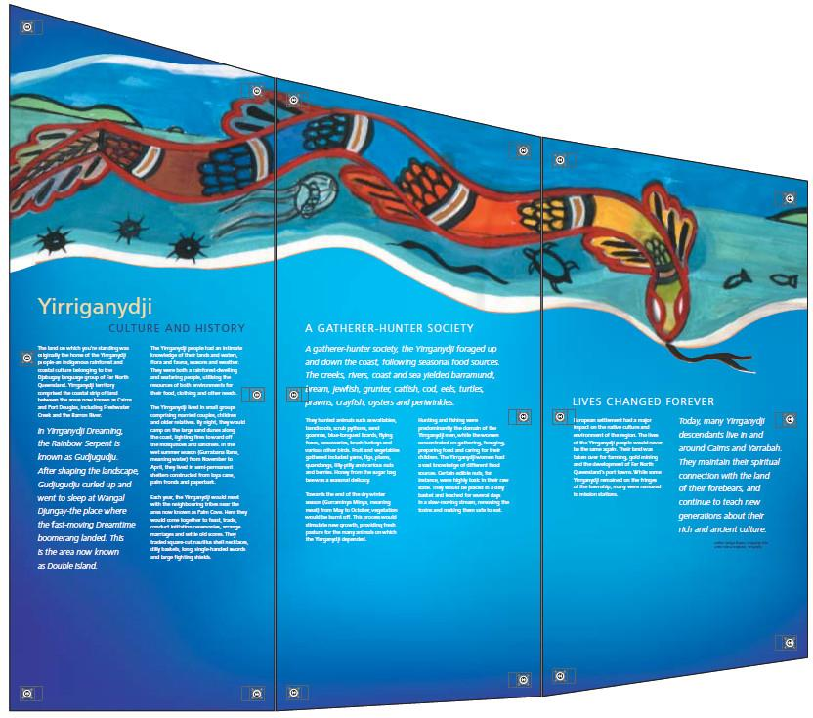 *Figure 3: The above image is about Yirrganydji culture and history*

#### Section 2.2.7.2: Religion

Roman Catholics made up the largest strict group in Cairns North in 2016, with a proportion of 16.4%, while 20.4% of people didn't identify with their religion and 32.6% of people had no religion. (Cairns Regional Council | Community profile | Religion, 2022)

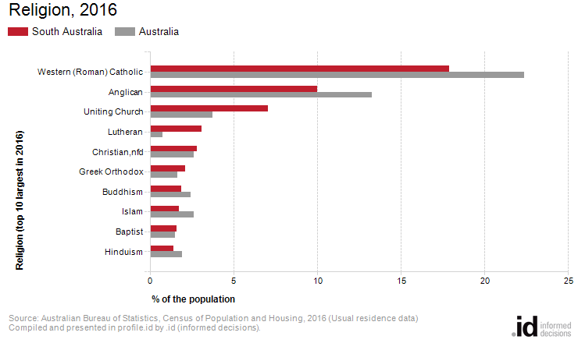

*Figure 4: The graph above demonstrates the religions in south Australia*

#### Section 2.2.8.3: Language

One of the five dialects of the Djabugay language is Yirrgay, which was spoken by the Yirrganydji Pama Kulpul-Parra (people of the saltwater). The other dialects in the group were Guluy, Ngakali, Djabugay, and Bulway; Yirrgay was the most southern. The Yidinji people, their near neighbors, lived in the area south of Gimuy (“Indigenous Languages Map of Queensland,” n.d.).

# Section 3: Stakeholder Analysis

## **3.1 Environmental organizations**

Australian Native Plants Society (ANPSA**) Environmental organizations**, which play a critical role in maintaining the well-being of our land and the wise use of its natural resources, are one of the project's stakeholder groups. These organizations put in an unrelenting effort to promote environmental awareness, push for strong environmental laws, and participate in conservation and preservation activities. One of the most influential environmental groups is Wildlife Fund. These groups use a variety of tactics, such as research, teaching, lobbying, and direct action, to accomplish their goals. As a result of their actions, they have successfully increased public awareness of important environmental issues like climate change, deforestation, and species extinction.

### 3.1.1 (ANPSA) Environmental organizations what they want in this project,

Australia's environment and natural resources are protected and restored through environmental organizations, which are nonprofits. It has spent nearly 50 years working for the protection of the environment. It has successfully set up several in successful setting up several numbers of important environmental protections, including the preservation of the Great Barrier Reef and the stop of logging in old-growth forests. The organization engages in various range of activities, including advocacy, research, education, and community involvement, to meet its objectives. Among the principles that direct its work are sustainability, environmental justice, and caution.

In order to combat environmental issues, including deforestation, climate change, and pollution, The Wilderness Society, an Australian conservation organization, participates in lobbying, campaigns, and community organizing (The Wilderness Society, 2022), About Us. Through their efforts, the group has been successful in securing environmental protections, including the formation of national parks and reserves and the conservation of endangered species. Also, people should be informed about the value of these plants to civilization and the ecosystem. The environmental movement to preserve and promote the use of native Australian plants.

The conservation organization, The person in charge of this program, is devoted to protecting the native plants and bush tuckers. The environmental organization might promote the project to the general public and provide advice on how to grow and maintain local flora. They might also work on programs and educational materials to promote awareness of the cultural and environmental value of indigenous flora and bush food.

### 3.1.2 Australian Native Plants Society (ANPSA) Environmental organizations power and their intrests

In Australia, the organization may have much control over a project incorporating native plants and bush tucker, but they are nevertheless inspired by it. The ANPSA is a well-known and well-respected group that significantly influences public opinion and legislation surrounding native plants and their ecosystems. Its mission is to safeguard and restore Australia's environment and natural resources. The organization has a significant number of members and works at the municipal, state, and federal levels, allowing it to engage with decision-makers and advance environmental protection and preservation. The scope and complexity of the project, the level of community involvement and support, and the regulatory climate in which the project is being proposed are just a few of the variables that would determine the power and effect of ANPSA on a project.

**How would the stakeholder be affected if no solution was found?**

All of the natural creatures that inhabit a certain location, such as birds, insects, and small mammals, regularly eat bush tucker and local flora for sustenance.

If these plants are not protected or properly managed, their disappearance might cause a decline in biodiversity and affect the ecosystem's overall health. This has been observed in certain areas where native flora has been eliminated or replaced by non-native species, causing indigenous fauna to lose their home.

**If a solution was found, how would that affect stakeholder**

Better environmental results, the solution could lead to the recovery and preservation of natural ecosystems, which could improve environmental outcomes like soil health, water quality, and biodiversity.

## **3.2 Indigenous communities.**

### 3.2.1 Introduction

The Yirrganydji community is one of the main participants in an initiative to build a nursery for native plants and bush foods. Their participation would be essential to the project's success. The Yirrganydji people have a significant stake in this project's success since native plants and bush truckers are integral to their cultural legacy.

### 3.2.2 Indigenous communities (Yirrganydji tribe) what they want in this project,

Indigenous Australians of the **Yirrganydji** tribe own lands surrounding the Cairns region. They take part in any attempt that calls for the usage or management of their long-time guardians and has a profound culture. The spiritual connection to the environment and ancestral land belongs to them. The core of Yirrganydji culture, like that of many other Australian Aboriginal traditions, is a strong responsibility to protect the land and its people. (EWB challenge)

3.2.3 Indigenous communities (Yirrganydji tribe) power and what about their interest**,**

People from the Yirrganydji tribe could also have financial reasons to want this initiative to succeed. According to a National Native Title Council decision, indigenous peoples have the right to participate in economic and development opportunities in their native homelands. Consequently, the effort could be able to provide the Yirrganydji people with work opportunities and financial advantages. The project's objectives may change according to the Yirrganydji community. These successes could include things like economic growth, cultural preservation, and environmental sustainability.

### 3.2.4 How would the stakeholder be affected if no solution was found?

If a solution is not discovered, the Yirrganydji people won't be able to teach the next generation about bush foods and native flora, which might have short-term negative impacts like losing one's cultural identity and history. They are unable to maintain their cultural history and traditional knowledge. There may be a loss of biodiversity and ecosystem health since indigenous people, who have considerable environmental expert knowledge, are the first to notice dangers to ecosystems.

### 3.2.5 If a solution was found, how would that affect stakeholder

Positive cultural and economic effects also arise. The project may provide employment opportunities and support the economic development of the Yirrganydji community. Young Yirrganydji people's traditional knowledge will also be strengthened through the program.

## **3.3 Local Government**

### 3.3.1 Introduction

Australia's local government, The Cairns Regional Council, is in charge of a broad range of additional services and amenities for the local population in addition to handling rubbish, roads and transit, parks and gardens, libraries, and community facilities. And it. Collaborates closely with local businesses and industry to promote growth and investment, which greatly contributes to the region's economic development.

### 3.3.2 The Cairns Regional Council what they want in this project

The Cairns Regional Council’s main scope In the case of its Greening our city strategy, which involves planting bush tucker and other vegetation in public spaces, the Cairns Regional Council (CRC) consulted with stakeholders, such as Traditional Owners, Indigenous groups, and environmental organizations, to ensure that the project was respectful, sustainable, and culturally appropriate. Concerns about the project's effect on their lands were not affected by something. Engaging and involving the community in decision-making is one of the CRC's main goals.

### 3.3.3 The Cairns Regional Council power and what about their interest,

The Cairns Regional Council’s interests in the addressed concerns about the project's effect on their lands. Its generosity about the project's effect on their lands through collaboration with nearby farmers and landowners. The CRC is dedicated to fostering sustainable behaviors and preserving the natural environment in the area. There may be limited control over a project involving planting bush tucker in the Cairns area where the Cairns Regional Council (CRC), which is constitutionally required to make decisions on behalf of the people, has no power. The CRC, however, is committed to interacting with stakeholders and taking into consideration their concerns and opinions when making decisions.

### 3.3.4 How would the stakeholder be affected if no solution was found?

In the near future, the CRC could pass up chances to support cultural heritage, develop sustainable food production, and boost biodiversity. The public's opinion of the council's commitment to sustainability and cultural heritage may be negatively damaged if it is seen that it needs to take action on planting bush tucker. Lack of planting of bush tucker may lead to a decrease in biodiversity and the availability of vital indigenous species' food sources.

### 3.3.5 If a solution was found, how would that affect stakeholders?

The council's commitment to sustainability and cultural heritage may be favorably benefited by taking action on planting bush tucker. Temporarily, planting bush tucker may boost biodiversity by  Through reducing food miles and supporting local farmers and food producers over the long term. Get better public health.  Over time, having access to healthful food in the area can improve public health.

## **3.4 Commercial industries**

### 3.4.1 Introduction

In many environments across the world, native plants and bush trackers play a significant role in delivering crucial ecosystem services, including soil conservation, erosion control, and nutrient cycling. These habitats and their indigenous flora are frequently directly impacted by commercial businesses, including the forestry and agriculture sectors. In order to promote sustainable agriculture and forestry operations, it is crucial for these businesses to comprehend the significance of native plants and bush trackers.

### 3.4.2 Commercial industries what they want in this project

Commercial companies may contribute to the preservation and protection of native flora and bush trackers while still achieving their economic goals by using sustainable land management techniques. Using techniques like rotational grazing, using native plants as feed, and minimizing the use of pesticides and other hazardous chemicals are a few examples of what this entails. Moreover, using indigenous flora and bush trackers in their operations may be advantageous for many commercial sectors. For instance, certain native plant species may be used as a source of food and fiber or for medicinal purposes.

### 3.4.3 Commercial industry’s power and interest,

Key stakeholders of native plants and bush tuckers, Commercial companies may seek to protect and responsibly use these assets by being aware of the importance of these plants and their part in sustaining healthy ecosystems. The value of native flora and bush trackers must be acknowledged by all parties involved in the commercial industries. And efforts must be made to develop sustainable methods that promote their preservation and utilization.

### 3.4.4 How would the stakeholder be affected if no solution was found?

A fall in biodiversity may have a detrimental effect on the health and productivity of ecosystems and can be brought about by the extinction of native plants and bush trackers. This might lead to lower crop yields, more soil erosion, and poorer water quality, all of which could have an adverse economic impact on commercial sectors. And Businesses that are perceived as causing the extinction of natural flora and bush trackers might damage their reputation.

### 3.4.5 If a solution was found, how would that affect stakeholders?

The production of ecosystem services, including soil conservation, water regulation, and pest control, can be improved through the protection and management of native plants and bush trackers. For commercial enterprises, this may result in higher production and better environmental effects. When native flora and bush trackers are managed sustainably, it is possible to increase our ability to withstand environmental and financial shocks like drought or market volatility. For commercial businesses, this may lead to longer-term economic outcomes that are more solid and durable.In general, stakeholders in commercial businesses can reap major advantages from developing ways to maintain and sustain native flora and bush trackers, including better environmental results, expanded economic possibilities, and decreased dangers.

## **3.5 Dawul Wuru Rangers**

### 3.5.1 Introduction

The Dawul Wuru Rangers are a team of indigenous rangers that primarily focuses on the conservation and management of the Land and Sea country, through the Yirrganydji land and sea ranger program, set up by the Dawul Wuru Aboriginal corporation. In an

interview with 100 Climate Conversation, Gavin Singleton who is one of the project managers at the corporation and coordinates the land and sea ranger program says that the corporation is fairly new, as it was set up in 2010, and they started the ranger program in 2015, with only two rangers at that time (add reference: <https://100climateconversations.com/gavin-singleton/>). Some of the objectives that were aimed to be achieved by establishing the land and sea ranger program are conservation, management, and sustainability of Land and Sea Country along the North Queensland coast from Cairns to Port Douglas; preservation of the rights as Traditional owners and connection to land and resources; creation of long-term job opportunities and economic stability for individuals, families, and the community, (add reference: https://dawulwuru.com.au/land-management/ranger-program/) These objectives are important to consider when designing our solution, therefore making them a Key stakeholder in this project.

### 3.5.2 Needs and Wants

The Dawul Wuru rangers have a high level of power and interest, as they are responsible for managing the Land country and also will be most likely to take the lead in educating others about bush tucker and bush tucker gardening.

The rangers are committed to maintaining sustainable practices in all their activities, so one key need will be to establish a system where plants grown in the nursery are harvested in a way with the conservation of natural resources in mind so that they can ensure that plants will continue to regenerate and provide a long term source of food and resources.

In addition to this, the rangers are focused on

### 3.5.3 Impacts of the Project on the Stake Holder

Strengthen connection to the land

One of the main objectives of the ranger program is to preserve the connection to land and culture, and building a nursery to cultivate native plants will provide them with the opportunity to do so. This would allow them to carry on their traditional practices and teach younger generations, which would help strengthen connections to the land.

The project also holds the potential to provide economic benefits, which align with the objective of the ranger program to create economic stability for families, individuals, and the community. The native plants grown could be sold, providing a source of income, which will have a positive impact on the community by increasing spending power for future development initiatives and creating new job possibilities.

# Section 4: Design Requirements

## 4.1 Design Criteria

Our goal is to establish a bush tucker nursery for the Yirrganydji people living in the Cairns region to provide a sustainable source of traditional food, while also preserving the cultural heritage of the Yirrganydji community. To achieve this we have taken into account the needs and objectives of the stakeholders relevant to the project (mentioned in section 3.0), and have developed a set of design criteria, in order of importance, to guide us in creating an effective solution.

### 4.1.1 Sustainability

Sustainability means creating a project that promotes environmental health and ecological balance in the long term. To achieve this, there are some specific factors that should be considered.

Water conservation is key, and the plant nursery should implement efficient irrigation systems such as drip irrigation to reduce water waste. It can also supplement its water needs through rainwater harvesting.

Waste management is also crucial, and the nursery should strive to minimize waste generation through composting, recycling, and repurposing. Any hazardous waste must be disposed of responsibly.

To reduce reliance on fossil fuels, the plant nursery should use renewable energy sources like solar or wind to power its operations.

Additionally, the nursery should priorities the growth of a diverse range of native plants, including endangered species, to promote biodiversity conservation.

### 4.1.2 Safety

Maintaining safety is a crucial component of any plant nursery's operation. To achieve this, the nursery must take proactive measures to protect its staff, visitors, and the plants themselves.

One of the primary ways to achieve this is by implementing safe working practices. This includes ensuring that employees wear appropriate protective equipment when handling hazardous chemicals or machinery. Furthermore, all equipment must be regularly inspected and maintained to minimize the risk of accidents or malfunctions.

Adequate first aid facilities and fire safety measures are also essential. This may involve installing fire extinguishers and smoke detectors throughout the nursery, as well as developing a comprehensive evacuation plan in case of emergency.

Moreover, protecting the plants from pests and diseases is equally important. The use of natural and non-toxic pest control methods such as companion planting and biological controls can help prevent harm to the plants and surrounding ecosystem. This approach not only ensures safety but also promotes a sustainable and environmentally conscious operation.

### 4.1.3 Resource Availability

One of the key things to consider is resource availability. We want to make sure that the nursery has everything it needs to grow and maintain healthy native plants.

So, here are some specific resources that we need to think about when designing the plant nursery:

Firstly, we need to make sure that we have enough land to grow the plants. This means making sure we have enough space for planting, propagation, and storage. We don't want to overcrowd the plants or run out of room, so this is an important factor to consider.

Next, we need to make sure we have a reliable source of water. This could be a well, bore, or even a rainwater harvesting system. We need to make sure the plants get enough water to grow and thrive, so having a good water source is crucial.

We also need to think about soil quality. The plants need to grow in healthy, nutrient-rich soil that's free of contaminants. This means testing the soil and making sure it's suitable for growing native plants.

One of the critical requirements of the yirrganydji people as stakeholders is a seed bank, to meet this requirement we need to ensure that we have a reliable source of native plant seeds, two possibilities are collecting and storing seeds from the local plants or partnering with other nurseries to get the seeds we need.

### 4.1.4 Cost (capital and operational)

When planning the design of a plant nursery, it is essential to take into account the costs involved. The expenses can be divided into two categories: capital costs and operational costs. Capital costs encompass the initial investment needed to set up the nursery, which includes things like purchasing or leasing land, building greenhouses, and installing irrigation systems. Operational costs, on the other hand, involve ongoing expenses like labor, water, electricity, and plant materials.

To keep costs to a minimum, it is advisable for the nursery to prioritize the use of sustainable and cost-effective materials. Examples of such materials could be recycled materials or locally sourced resources. Additionally, the nursery can lower labor costs by utilizing efficient and automated systems such as drip irrigation and plant propagation trays. By implementing these measures, the nursery can save money while still maintaining a high level of quality.

### 4.1.5 Economic Viability

Economic viability is another essential consideration. The project must generate sufficient revenue to cover its costs and provide a sustainable income for stakeholders.

A cost-benefit analysis should be conducted to determine practicality, and the nursery should diversify its revenue streams to reduce reliance on any one source. For example, it could sell plants or offer educational programs to tourists.

## 4.2 Design Constraints

In the summer, the Cairns region experiences exceptionally high temperatures and humidity, which will have a detrimental effect on the environmentally sustainable aspect of our design (Weather in Cairns - Tourism Australia, 2020).(www.australia.com,2020).

Sourcing the best materials for the crucial parts of our final design will also be difficult because there aren't enough different materials and alloys available locally, and shipping them from other regions will be more expensive.

Rainy days and the lack sunlight due to this in the Cairns area will make it difficult to recharge the lithium-ion rechargeable batteries that power the green home from the solar panels.

The actual user experience of our final design may have been hampered by our lack of first-hand knowledge of the Cairns region and our reliance exclusively on secondhand information obtained from a variety of sources.

The local labor force, including the local Aboriginal population, might not be adequate or competent enough to complete the necessary work load, significantly hampering

our design.

With the current road system, hiring an excavator and a tractor , and transporting raw materials without causing any damage to them will be difficult to move into the selected construction site. For this endeavor to be a completed successfully, all of the aforementioned requirements must be met without going over the available resources and investment.

## 4.3 Design Criteria weighting summary table

|  |  |
| --- | --- |
| Criteria | Weighting |
| Sustainability | 30% |
| Resource availability | 20% |
| Cost | 20% |
| Economic viability | 10% |
| Safety | 20% |

# Section 5: Design concept solution

## 5.1- Outline of Concept

**The components we included in our Conceptual design and detailed explanation of any changes made:**

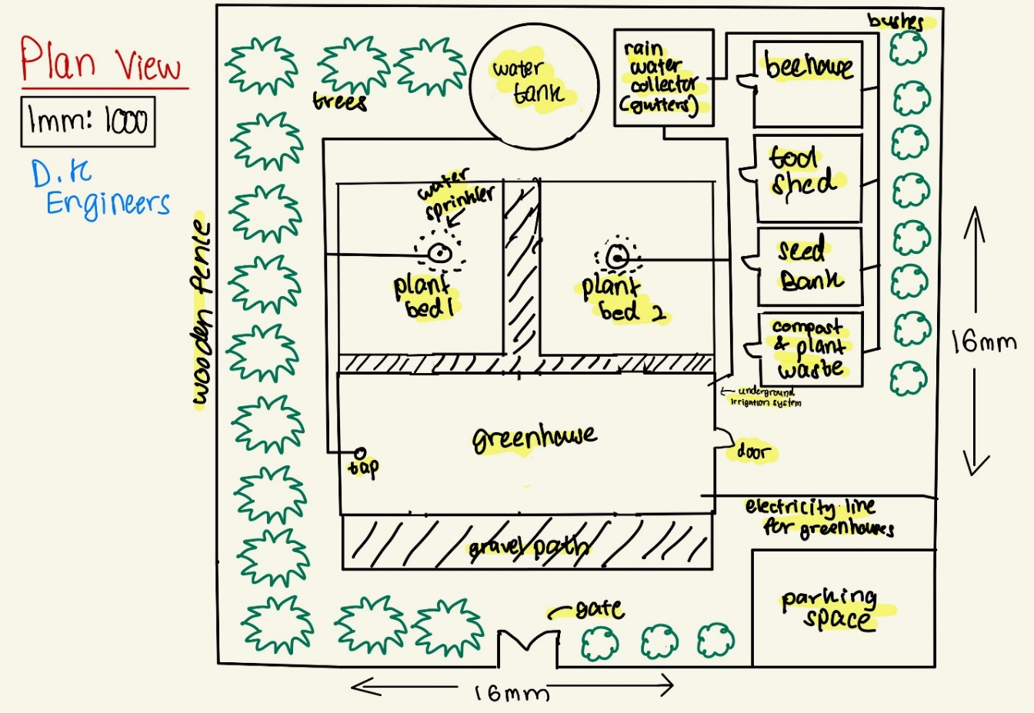

1. Outdoor plant bed-
   * Our outdoor plant bed was initially designed with the mind of growing the plants on a single layer of soil. What we decided to change was to make elevated plant beds separate from each other. The advantage of this is better water retention in the soil, easier to grow different plants in separate sections and a connected gutter system for water drainage.
2. Greenhouse

* We decided on growing plants using the aqua-ponics method in our greenhouse. Plants that are sensitive to changes in temperature, humidity, moisture, etc. are grown in here. Which have several advantages that include the ability to grow plants year-round- as the system can be controlled to provide optimal growing conditions for plants and fish regardless of the season, efficient water use due to using less water, as the same water is recycled through the system, and being proven to produce higher yields of crops compared to traditional soil-based farming methods.

1. Bee house

* Without pollination, many vegetable crops would not be able to produce the fruit or seeds that are necessary for their reproduction. Bees are necessary for the organic pollination of plant seedlings and provides for. Therefore, a bee house is necessary for housing the bees which has additional projection from wasps and the weather.

1. Tool shed.

* The tool shed is used to store tools necessary for cultivation such as buckets, shovels, ploughs, tillers, hoes, rakes, etc.

1. Seed bank

* The preservation of plant genetic diversity depends on seed banks. A seed bank can safeguard the plants from adverse weather conditions and serve as a backup in case of a bad yield.

1. Compost and wastage hut

* Plant waste can be recycled and used as compost and waste that cannot be recycles must be stored before disposal.

1. Water tank and rainwater collector- Connected to the underground irrigation system.

* A water collection system was needed to collect and store the water needed for the plants and other purposes.
* Underground irrigation System- Water is distributed around the plant nursery through underground pipes connected to the water tank and rainwater collector.

1. Fence

* A fence is needed to secure the plant nursery from wild animals which could destroy the plants and thieves who would want to steal tools.

## 5.2 Conceptual Drawing Budget

|  |  |  |  |  |  |  |
| --- | --- | --- | --- | --- | --- | --- |
| *Materials* | *Uses* | *Dimension* | *Sources* | *Cost per unit (AUD)* | *Number of units required* | *Cost*  *(AUD)* |
| Solar panel | For electricity | **5kW** On-Grid Solar Power System | https://www.solitrapower.com/pricing/ | 6767.26 | 1 | 6767.26 |
| Pine lumber Wood | To build the frame of our greenhouse. | 19.6ft | https://www.indiamart.com/proddetail/australian-pine-wood-lumber-20159305362.html | (1sq ft.)0.73 | 19.6 ft | 14.308 |
| polycarbonate | cover to allow sunlight into the greenhouse while keeping the heat inside. | 3.5kg | https://roofing.lk/product/flat-solid/ | 18.66 | 3 | 18.66 |
| Lighting system | To grow plants year-round. | 18W 2′ | https://www.moglix.com/lighting-luminaries/led/211200000 | 6.20 | 4 | 24.8 |
| Watering system | to make sure your plants get enough water (pipes). | Diameter 20 | https://plumbingsales.com.au/pvc-dwv-drainage.html | 15.6 | 50 | 780 |
| Sprinkle | For watering the plants. |  | www.bunnings.com.au/products/garden/watering-accessories/hose-end-sprinklers/sprinklers | 9.35 | 12 | 112.2 |
| Bamboos | We are using it for gutters and to construct the fish tank. | Recycled |  | No cost |  | No cost |
| Water pump | To get the water from the fish tank to the overhead tank. | 0-200L/Min | https://dalangpump.en.made-in-china.com/product/XbCnOIHuMBWk/China-Wqd6-16-0-75-Centrifugal-Submersible-Sewage-Water-Pump.html | 59.81 | 1 | 59.81 |
| Doors | To enter our greenhouse | Width max:  18mm  Height max:  27mm | https://www.yywindowssupplier.com/doors/aluminum-french-doors/broken-bridge-aluminum-french-doors.html | 1532.5 | 1 | 1532.5 |
| Total |  |  |  |  |  | 9350.238 |

# Section 6: Model drawings and Specifications

## 6.1- Drawings (Sketch up and AutoCAD)

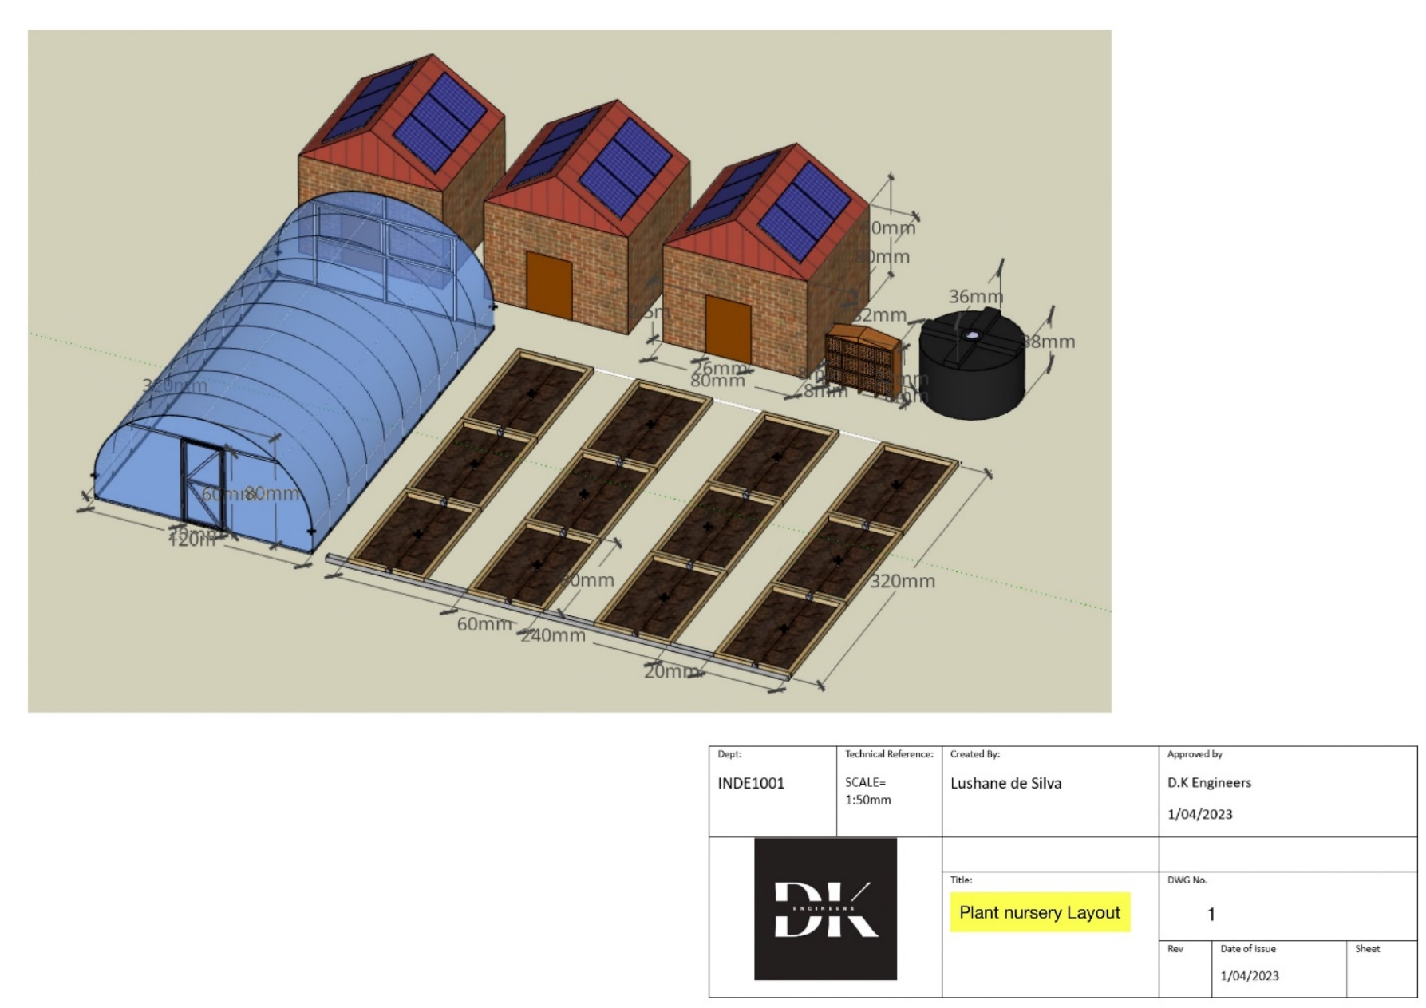

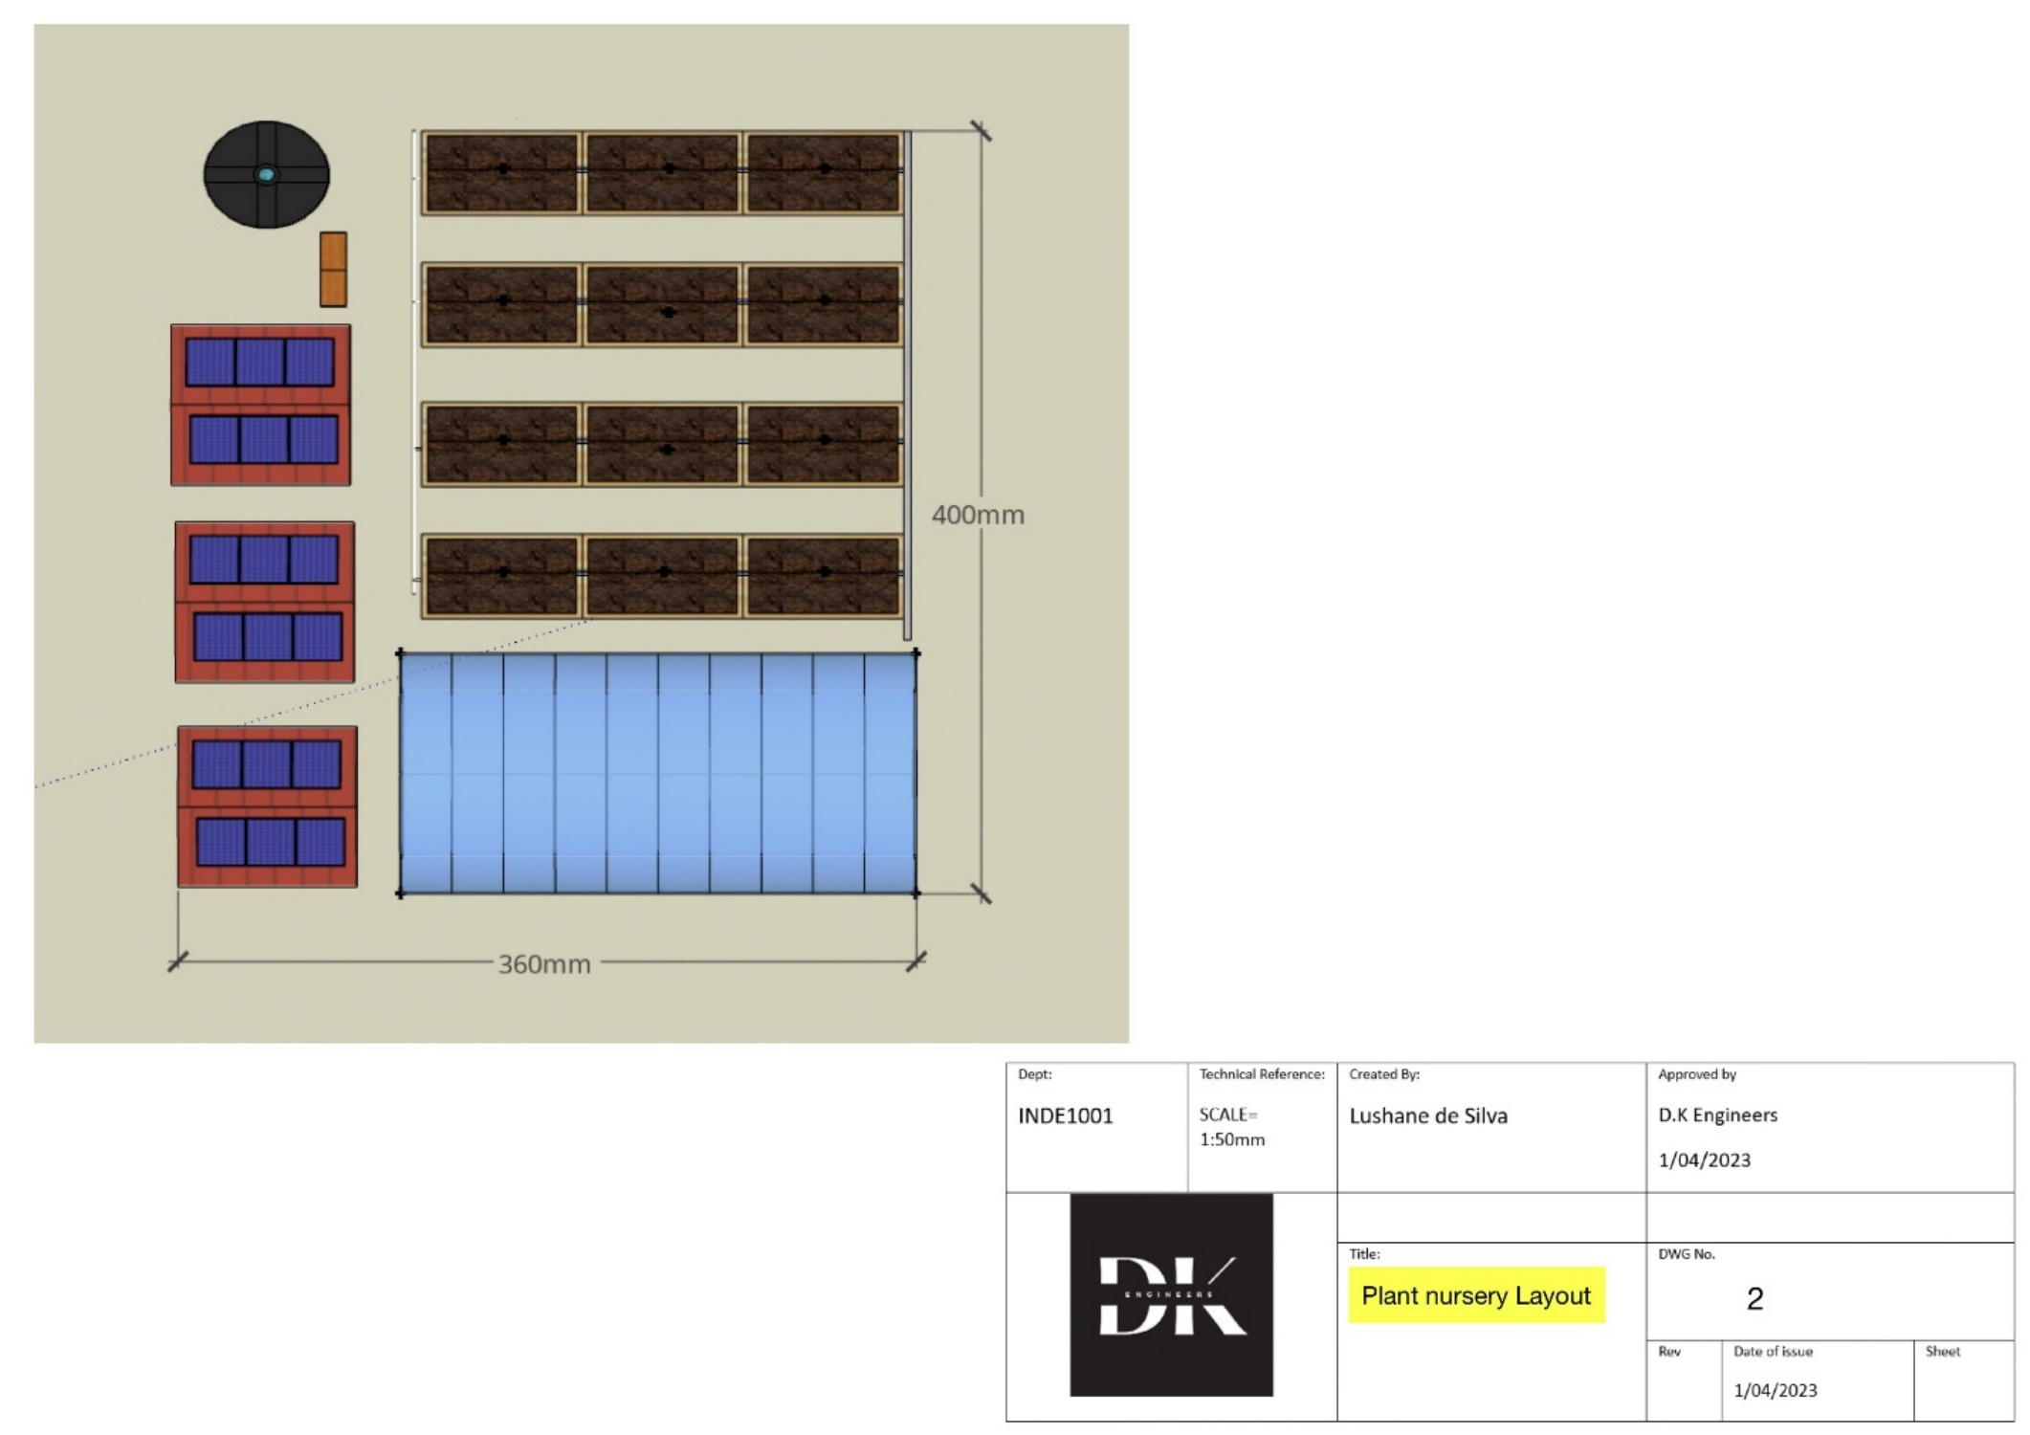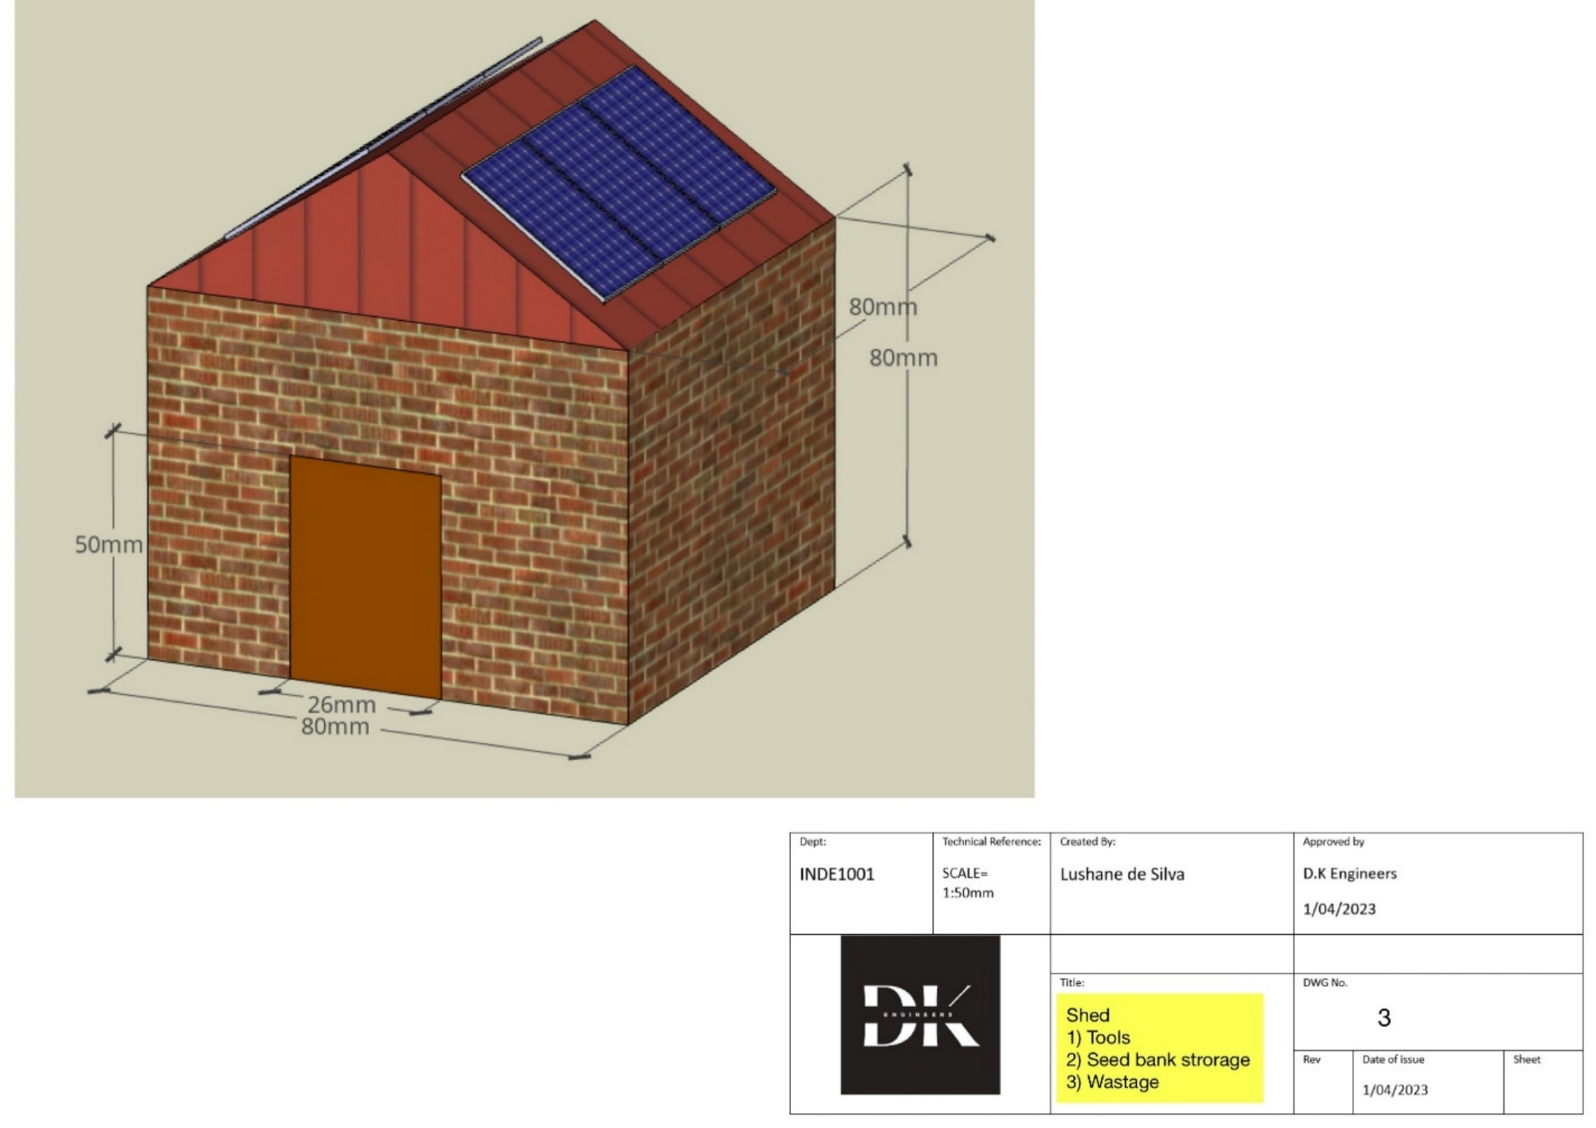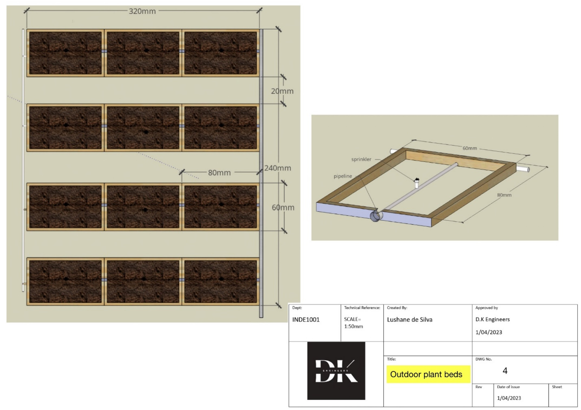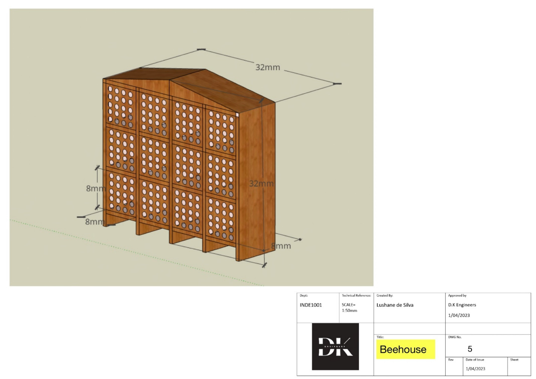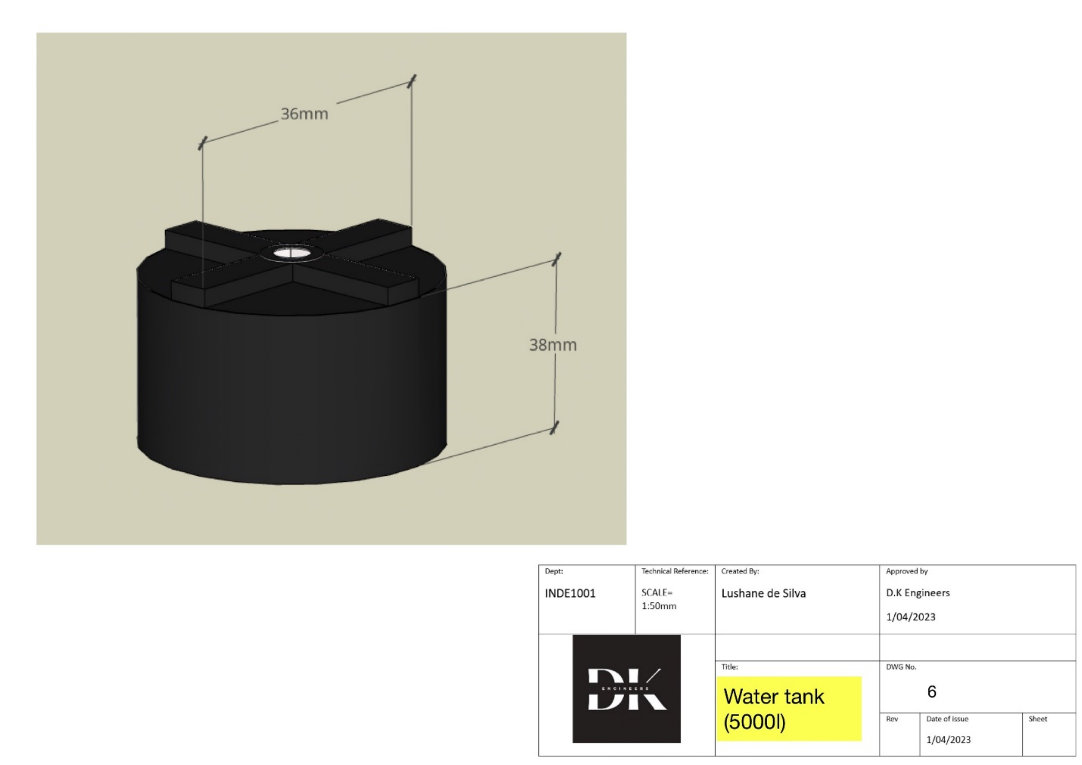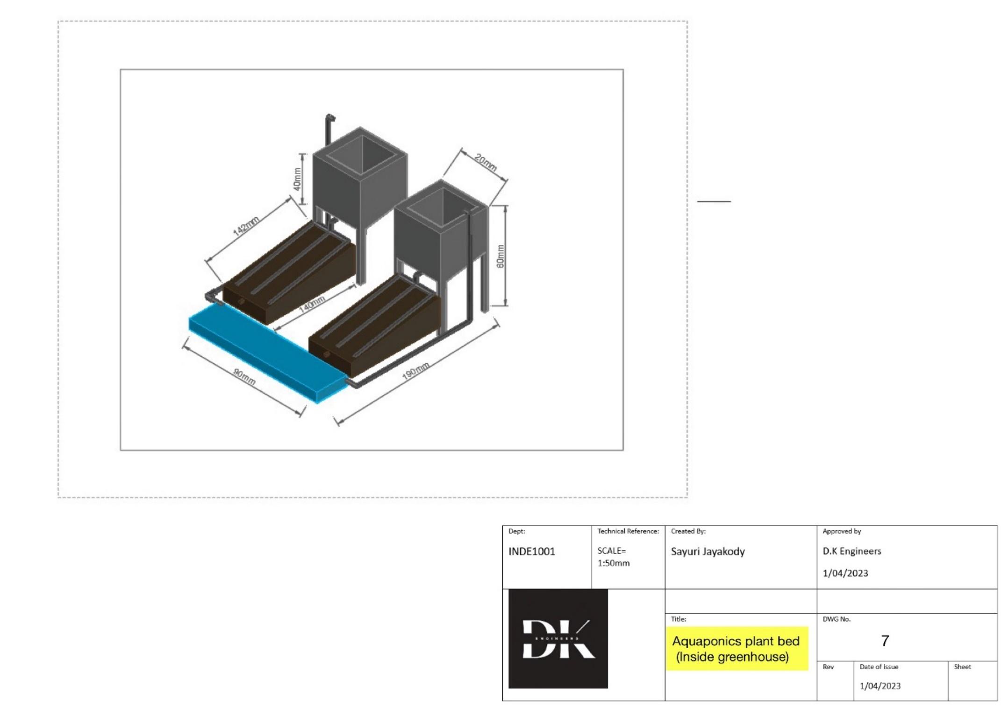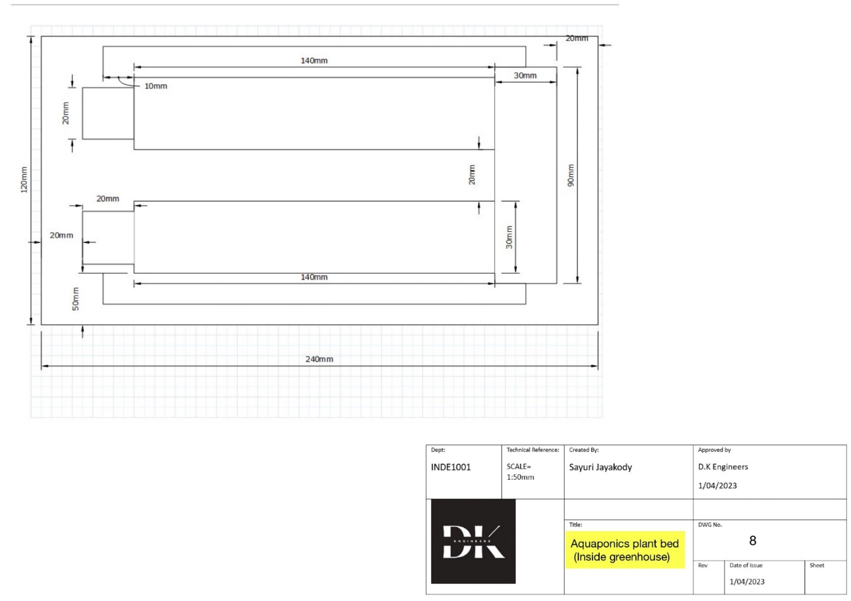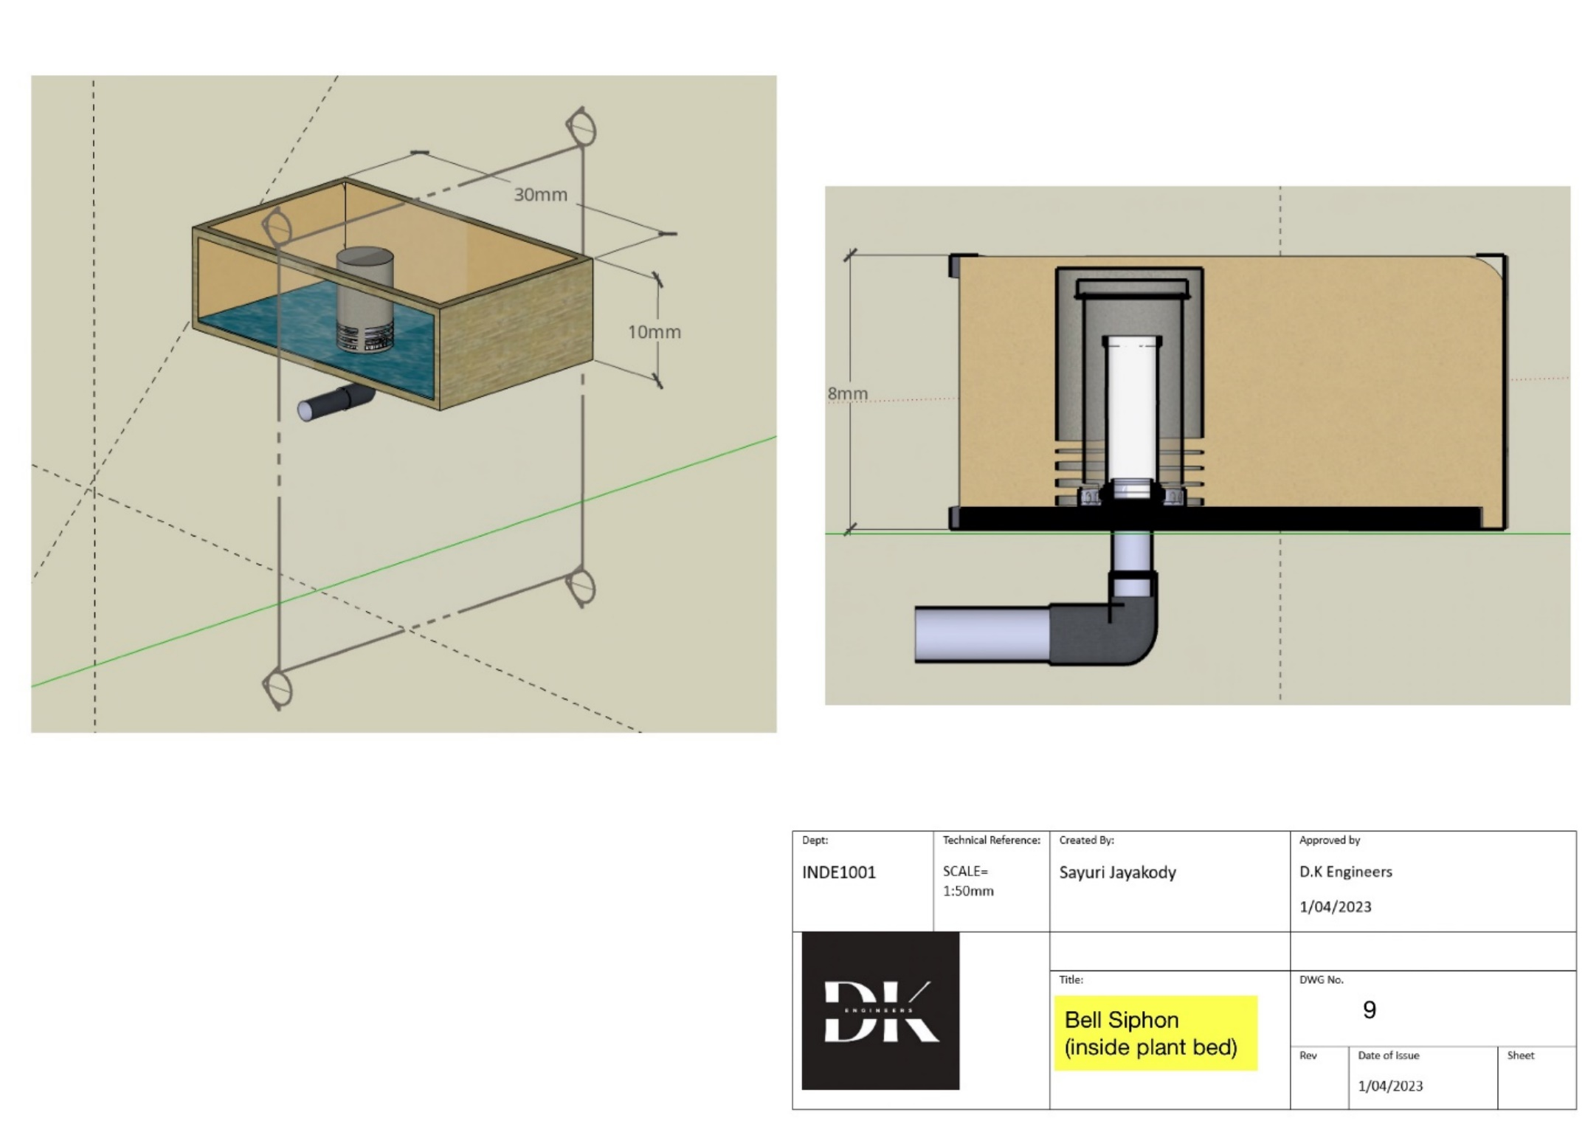

## 6.2 Specification

Note

* All the measurements are in millimetres, with a scale of 1mm : 50cm
* The tank and the plant beds in the aquaponic system should be inclined to a certain angle to get an uninterrupted water flow.
* When creating the water tank in the aquaponics system, the wall thickness in the 3D model is only intended to serve as a representation and is not required to be adhered to precisely

## 6.2.1 Bill of Quantities

|  |  |  |  |  |  |  |
| --- | --- | --- | --- | --- | --- | --- |
| Materials | uses | Dimension | Sources | Cost per unit (LKR) | Number of units required | Cost  (LKR) |
| Binding wires | To construct  The frame | 4490mm | Daraz.lk | 498/= | 1 | 490/= |
| Oil paper | To cover the  Greenhouse | 9.4" x 12.6" | Daraz.lk | 90/= | 4 | 360/= |
| Saline tube | To flow the water around the pants bed and to store water | 1mm x 3mm | Daraz.lk | 2,956/= | 1 | 2956/= |
| Cardboard | For the structure of bee house, seed bank and tool shed | 134400mm^2 |  | Recycled | Recycled | 100/= |
| Straws | For watering the plants | 1580mm |  | Recycled | Recycled | 100/= |
| Mud clay | To make plant beds | 60mm*80mm | Daraz.lk | 110 | 2 | 220 |
| syringe | For pumps the water |  | https://www.bbraun.com/en/products/b/original-perfusorsyringe50ml.html |  |  | 450/= |
| Binder gum |  |  | Daraz.lk |  |  | 89/= |
| Total |  |  |  |  |  | 4765/= |

### 6.2.2 Tools List

* Heat Gun
* Pliers
* Binder gum
* 30cm Ruler
* Retractor blades Scissors

### 6.2.3 Methodology

Greenhouse

* **Framework**

1. To make the base of the frame cut 2 pieces of the binding wire measuring 245m and another 2 pieces measuring 125m, join all the four by twisting it with a plier at the end and shape it to a rectangular form.
2. Form 10 semi circles consisting of arc length 255mm and then fix it to the longer side of the base keeping equal distances apart.
3. Join the two semi circles (first and the last) from the top to form a roof using five binding wires and cut off the excess after twisting with a plier.
4. Five binding wires should be attached such that they are in equal distances apart.
5. Cut two pieces of binding wire with length 65mm and another piece of binding wire with length 25mm, join the wires to form the door of the greenhouse by twisting the edges.
6. Attach the free ends of the longer wires to the base of the green house (at the front face).
7. Join the upper horizontal wire of the door to the front semicircular arc using two pieces of binding wires with appropriate length.

* **Outer covering of the greenhouse**

1. Cut 10 rectangles out of the oil paper measuring 15mm by 25mm.
2. Paste the strips along the wire frame using binder gum, wrapping the 2.5 mm of each side of the oil paper strip along the wire.
3. Cover the front and back face of the greenhouse using an appropriate piece of oil paper(paste the oil paper along the wires and cut off the excess amount of paper).

* **Piping**

Form the piping system of the plant bed by joining straws together to the required length and heat them to seal at the end, make sure to heat the outer parts of the conjoined straws with a heat gun to make sure there is no leakage

* **Aquaponics system**

1. Using two cut bottom sections of two plastic disposable water bottles (height 40mm) construct the tanks and then add inclined supports to the water tanks.
2. Construct two inclined support structures using mud clay.
3. Height of the taller side of the support should be 20mm and the height of the shorter side of the support should be 15mm to create the inclination.
4. Construct a small barrier on the shorter side of the support using mud clay to prevent sliding of the water tank.
5. Make a hole at the front face (face with shorter support) in each of the two water bottles making sure that it’ll just be enough for the two saline tubes to pass through and then heat the two holes after the tubes are inserted to prevent leakage.
6. Other end of the saline tube attached to the water tank should be attached to saline tube of length 20mm (These saline tubes should be attached such that they are perpendicular to each other)
7. Seal the ends of the horizontal tube to prevent leakage.
8. Make three holes at the two ends and in the middle of the horizontal tube.
9. Attach three saline tubes in length 142mm to the three holes of the horizontal tube (They should be perpendicular to the horizontal tube and they should be able to be placed along the inclined plane of the plant bed). Heat the joints to prevent leakage.
10. Seal the free ends of the three tubes.
11. Make holes with equal distance apart in all three saline tubes (to create the drip irrigation.).
12. Follow the same procedure to create the drip irrigation system of the other plant bed.
13. At least a total length of 430mm of saline tube will be needed to create the drip irrigation.
14. To create the fish tanks cut out a disposal plastic water bottle from the mouth to base (longer side of the bottle) and make a slight hole in either side which will be just enough for the saline tubes to pass through and heat the joints using a heat gun.
15. Make the plant beds with an inclination using mud clay (the plant beds should be made as inclined containers using mud clay).
16. Height of shorter side of the plant bed base should be 6mm from the ground and height of taller side should be 10mm from the ground. Length of inclined base is 350mm.
17. Walls of the plant bed should be created using mud clay on top of the inclined base with a height of 10mm.
18. Make a hole in the middle of the plant beds (to insert the outlet tube of the bell siphon.) with a depth of 4mm.
19. Make a hole in the front face of the inclined base (face of shorter side) such that a saline tube can be inserted through the inclined base until it reaches the middle hole of the plant bed.
20. To demonstrate the water pumping system, take two saline tubes with appropriate length and connect each with a syringe and connect the free ends of the tubes to the water tanks.
21. Compress the syringe with water to demonstrate the water pumping system.

* **Bell siphon**

1. Take two empty sanitizer bottles (one larger and one smaller)
2. Cut the larger bottle about two thirds of the way from the top so this will be the bell part of the siphon.
3. Cut the smaller bottle about one third of the way from the top (this will be the standpipe of the siphon.)
4. Make sure that the lid of the larger bottle is sealed properly.
5. Make holes in open end of the bell part to let water enter to bell siphon.
6. Place the smaller bottle part (standpipe part) such that the open end is at top and the part with the lid should be at the bottom.
7. Lid of the smaller part (standpipe part) should be open and it should be connected to a saline tube (Outlet of the bell siphon which will carry water to the fish tank.)
8. Heat the end of the saline tube which connects to the lid of the smaller part to prevent leakage of water.
9. Place the larger part of the bottle (bell part) on the smaller part of the bottle (standpipe). Larger bottle part should be placed covering the smaller bottle part (standpipe).

* **Outside Plant beds**

Make plant beds of width 60mm and length 80mm each using mud clay.

* **Rainwater tank**

Cut out a bottom section of a plastic disposable water bottle with a height of 38mm.

* **Seed Bank**

Cut out 4 square cardboard pieces of length 80mm and paste them together to form the walls of the seed bank.

Cut two rectangles of length and breadth 80mm and 50mm respectively.

Join the two rectangles to form the roof.

* **Beehive housing**

Cut out 4 square cardboard pieces of length 80mm and paste together to construct the walls of the bee house.

Cut two rectangles of length and breadth 80mm and 50mm respectively. Join the two rectangles to form the roof

* **Tool shed**

Cut out 4 square cardboard pieces of length 80mm and paste them together to form the walls of the seed bank.

Cut two rectangles of length and breadth 80mm and 50mm respectively.

Join the two rectangles to form the roof.

# Section 7: Tender Evaluation Criteria

It is necessary to use a Tender Evaluation Criteria document to evaluate the tendering company's level of knowledge. This is done to make sure the prototype is built accurately and the business operates effectively when making it. The subcontractors of other teams submit these proposals. The factors and the appropriate weightages that are taken into account are displayed in the chart below.

The following factors, with their respective weightings, will be used to evaluate each proposal that is received.

|  |  |
| --- | --- |
| Tender Evaluation Criteria | Weighting |
| Technical Capabilities | 30% |
| Cost effectiveness | 30% |
| Communication | 30% |
| Ability to meet deadlines | 10% |
| Total | 100% |

*Table 2: Main Tender Evaluation Criteria*

The evaluation of the pertinent factors that have been examined is displayed below. To ensure that the tendering businesses are fairly evaluated, each category is given a pertinent set of marks.

## 7.1 Technical capabilities:

The project deals with many requirements and challenges that need to be carefully considered and comprehended. Each project consists of numerous technical components, and the prototype is where these components are most prominent. The parties assess this prototype before making a decision on the final layout. Therefore, it is crucial that each team member has a thorough understanding of the plan and all of its components

**Three project-related questions must be answered, along with a sketch of the new design and any pertinent alternatives, in order to demonstrate that all members of the tendering business have a thorough understanding of the design.**

1) What approaches were taken into account regarding environmental sustainability? (2marks)

2) What innovative design strategies were used and why has the designers used them? (2marks)

3) Give a brief description of the community and their surrounding and explain how you would avoid any kind of harm to their culture and their surroundings. (6 marks)

The design requires a certain competency of handling construction tools and assembling parts.

|  |  |
| --- | --- |
| Evidence Provided | Marks |
| Providing evidence of previously completed projects to determine competency, and experience with construction tool | 5 |
| Providing evidence of previously completed projects | 3 |
| Experience with construction tools | 2 |

*Table 3: Score Allocate for Technical Capabilities*

## 7.2 Cost effectiveness:

It is required for the tendering company to be able to source re-usable materials and be able to get the maximum use of the materials present with a low wastage which would make this project both cost effective and also sustainable at the same time.

|  |  |
| --- | --- |
| Evidence Provided | Marks |
| Evidence of an innovating design/ solution to reduce cost and Use of sustainable Raw materials | 5 |
| Evidence of an innovating design/ solution to reduce cost | 3 |
| Use of sustainable Raw materials | 2 |

*Table 4: Score Allocate for cost effectiveness*

## 7.3 Ability to meet deadlines:

The prototype has to be analyzed and created efficiently with only a small amount of time for error corrections and challenges. If time is not managed or allocated efficiently, the prototype would not be a success. Considering time management, proof of a Gantt chart with the appropriate time frames should be submitted

|  |  |
| --- | --- |
| Evidence Provided | Marks |
| Submitting relevant documentation for the timeframes allotted, showcasing the group's submission dates and submitting the Gantt chart. | 5 |
| Submitting relevant documentation for the timeframes allotted, showcasing the group's submission dates | 3 |
| Submitting the Gantt chart. | 2 |

*Table 6: Score Allocation for the ability to meet deadline*

## 7.4 Communication

All members of the tendering company should be efficient at communication, which is a crucial position. When working on the project, members must communicate with a variety of stakeholders and customers, so it is essential that everyone can relate the points and criteria with assurance and ease.

Proof of attendance at project meetings and talks must be presented as proof. This could take the shape of images, videos, documents, or slides from a presentation. The ITP metrics pertaining to the peers' communication must also be presented as proof.

|  |  |
| --- | --- |
| Evidence Provided | Marks |
| Providing appropriate proof that each team member participated in project talks and displayed their communication abilities and giving evidence of ITP metrics | 5 |
| Providing appropriate proof that each team member participated in project talks and displayed their communication abilities | 3 |
| giving evidence of ITP metrics | 2 |

*Table 5: Score Allocation for Communication*

# Section 8- Conclusion

When formulating the design solution many factors were considered and examined. The impact of the project on different people and organizations is amply displayed through the analysis of the stakeholders. Design criteria and design constraints are the two major categories that make up the design requirements. The design criteria must be satisfied for the project to be effective. The main ideas assessed included cost, sustainability, safety in design, practicality, and materials used, and plant growth. These ideas are combined in the final design approach. The finished design vividly demonstrated how various theories and technological concepts were incorporated. Before completing the project, it was crucial to take into account the durability of the raw components and the project's cost-effectiveness. Many novel features were taken into consideration when creating the final design. (With sufficient reasoning). When developing the final design, analysis of the five conceptual designs accepted and rejected ideas provided a broader perspective. Owing to its practical applicability, a few of such ideas such as implementation of a vertical garden and the underground water irrigation system were rejected. Some of the many features that were eventually incorporated into the design include a greenhouse to aid the growth of native plants during their dormant period, an aqua-ponics irrigation system for irrigation, and a horizontal plant bed that is slightly inclined. All of the aforementioned problems have undergone rigorous analysis in our design project, and where appropriate, solutions have been put into practice.

In conclusion, it is clear that the chosen design works with the least amount of intricacy while maintaining affordability, sustainability, and durability. It is apparent that the plant nursery's final design will represent a significant breakthrough in the ongoing bush tucker and native plant scarcity crisis, ensuring the welfare and nutrition of the Yirrganydji people in the Cairns area while safeguarding its culture.

# Section 9- References

**2.1**

1. Australian Conservation Foundation. (2022). About Us <https://www.acf.org.au/about>

2. Engineering: Issues Challenges and Opportunities for Development https://unesdoc.unesco.org/ark:/48223/pf0000212239 3. Nature Australia - Nature Conservancy Australia.(2018) <https://www.natureaustralia.org.au/what-we-do/our-insights/impact-reports/>

**2.2**

1.Yirrganydji Country. EWB Challenge | Yirrganydji Country. (n.d.). Retrieved March 10, 2023, from <https://ewbchallenge.org/challenge/dawul-wuru-aboriginalcorporation/yirrganydji-country/>

2.Statisticsmore statistics. National Native Title Tribunal. (n.d.). Retrieved March 10, 2023, from <http://www.nntt.gov.au/Pages/Home-Page.aspx>

3. Agriculture and land. Agriculture and land - DAFF. (n.d.). Retrieved March 10, 2023, from https://www.agriculture.gov.au/agricultureland

**2.3**

1. Cairns Regional Council. (2023, March 7). Home. Cairns Regional Council. Retrieved March 12, 2023, from <https://www.cairns.qld.gov.au/>

3. Cairns Regional Council. (2021, October 5). Property information. Cairns Regional Council. Retrieved March 12, 2023, from <https://www.cairns.qld.gov.au/building-planning-business/property>

4. Cairns Regional Council. (2022, December 21). Sustainability. Cairns Regional Council. Retrieved March 12, 2023, from <https://www.cairns.qld.gov.au/community-environment/sustainability>

5.Cairns Regional Council. (2021, October 5). Community & Environment. Cairns Regional Council. Retrieved March 12, 2023, from <https://www.cairns.qld.gov.au/community-environment>

**2.4**

1."Bush tucker". Tourism Australia. Retrieved 1 April 2023, from <https://www.australia.com/en/things-to-do/aboriginal-australia/bush-tucker.html>.

2. City of Fayetteville Arkansas (03, Nov,2015) ,https://www.fayetteville-ar.gov/3028/Invasive-Plants-and-Native-Alternatives

**Cover page template from:** <https://www.canva.com/p/templates/EAE_yh4bhfY-minimalist-simple-annual-report/>

# Section 10-Appendices

## APPENDIX B- Concept design of team members

**Sayuri Jayakody - 211578902**

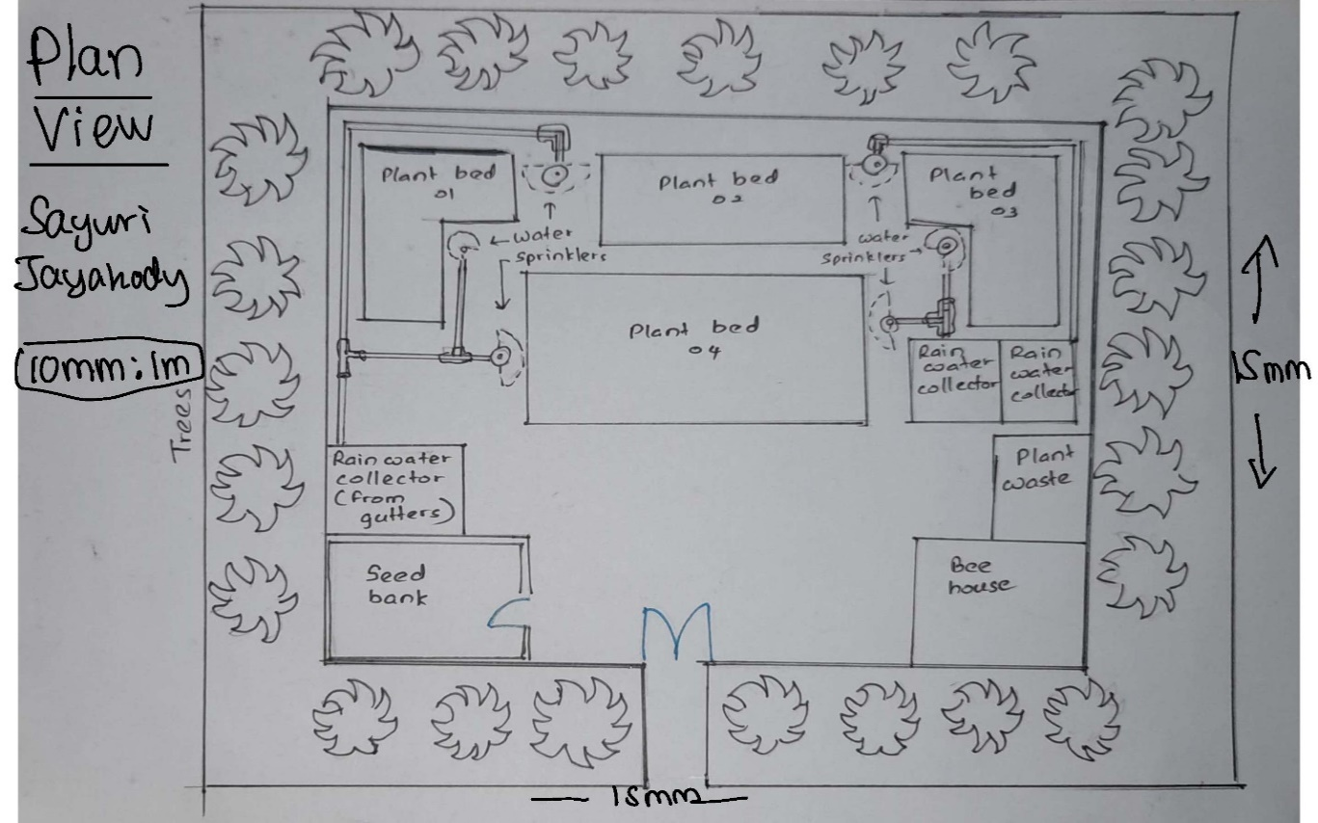

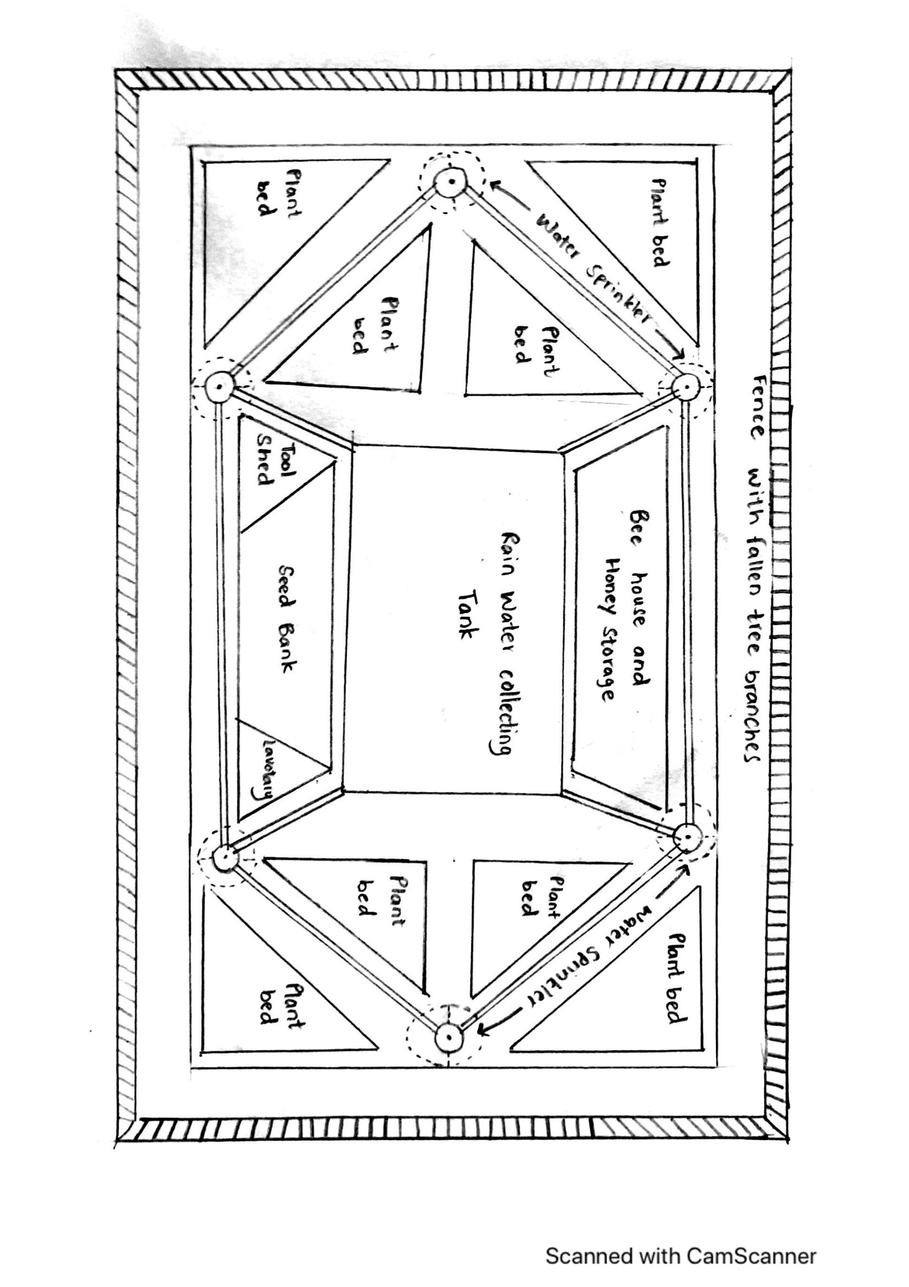

**Vinal Salgado – 212311425**

**Mohideen Mohomad Muhajir – 21570429**

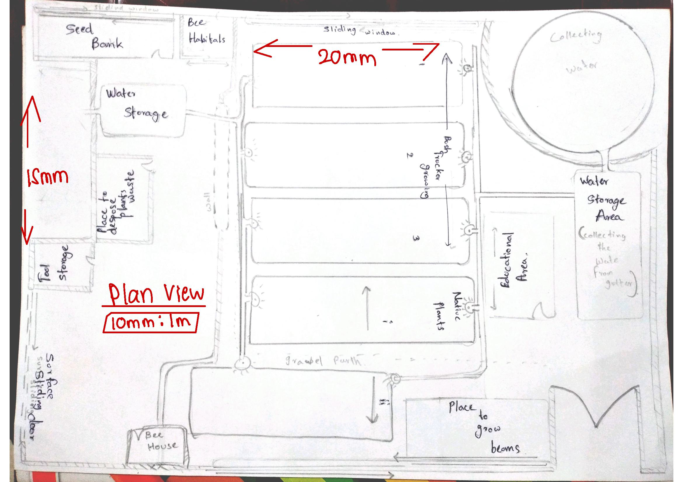

**Lushane De Silva – 21158744**

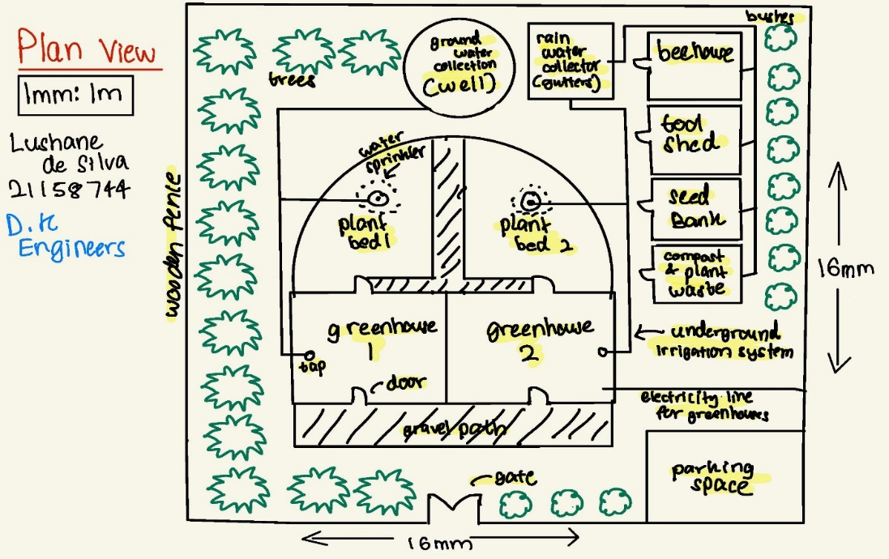

**Adithya Kulasekaram - 21154072**

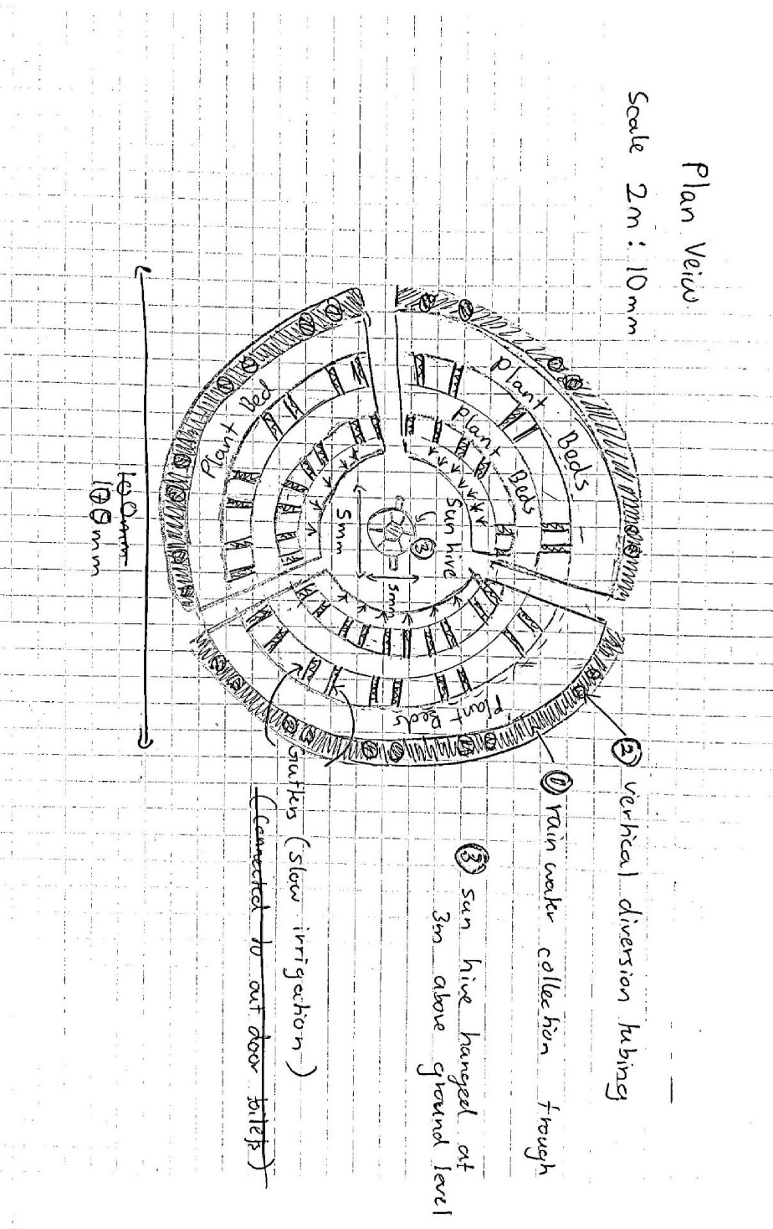

## APPENDIX C Table of contributions from each member

|  |  |  |
| --- | --- | --- |
| Name | Section Contribution | Percentage of Contribution |
| Vinal Salgado | Background *(Section 2)*  Design constraints *( Section 4.2)*  *TEC (Section 7)*  *Conclusion (section 1)* | 25 % |
| Mohideen Mohamed Muhajir | Stakeholder analysis (Section 3)  Conceptual solution Bill and Bill of quantities (Section 5.2 and 6.2.1 )  Cover page | 23 % |
| Adithya Kulasekaram | Design Requirements *(Section 4.1 and 4.3)* | 10 % |
| Sayuri Jayakody | Introduction *(Section 1)*  *Specification (Section 6.2)*  Methodology *(Section 6.2.2 and 6.2.3)*  3 of the Model Drawings *(Section 6.1, pg- 30,31, 32)* | 20 % |
| Lushane De Silva | 6 Model drawings *(Section 6.1, pg- 24,25, 26, 27, 28, 29*) and specifications  Concept solution *(Section 5 )* | 22 % |